Hamlet
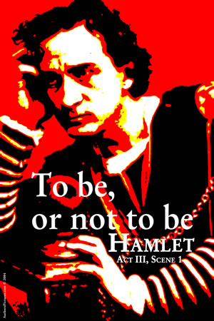
Reader’s Response
Entry #2
Act II

Directions
• Respond to 5 questions for this entry. Each response should be accompanied with at least 3-5 sentences of commentary and placed in your Readers Response Journal. Please follow the suggested format.

Scene I
- Why is Polonius sending Reynaldo to Paris? Be specific in your response and use a quote to help support your answer.

- In Act II Scene I Ophelia is upset about a conversation she had with Hamlet. Why? Use a quote to help support your answer.

- What reasons does Polonius give to describe Hamlet’s behavior toward Ophelia?

Scene II
- Queen Gertrude and King Claudius ask a favor of Rosencrantz and Guildenstern. Describe that favor and use a quote to help support your answer.

- Voltemand returns from Norway with what news regarding Fortinbras?

- King Claudius asks of Polonius – “But how hath she received his love?”(91). Why does this quote upset Polonius? Why does he react in this manner?

- What exactly is Hamlet saying to Polonius: “Let her not walk i’ th’ sun. Conception is a blessing, but, as your daughter may conceive, friend, look to it”(95)?

- Analyze and interpret what Hamlet is saying to Polonius: “Slander, sir; for the satirical rogue says ...”(95)

- In Act II Scene II (lines 250-255) Hamlet, Rosencrantz and Guilderstern speak in sexual puns. Translate what they are saying.

- With regards to the play in the play
  - What might it foreshadow?
  - How does it motivate Hamlet?

8. With regards to Hamlet’s soliloquy (lines 575-635), what does he plan on doing?

