Hamlet
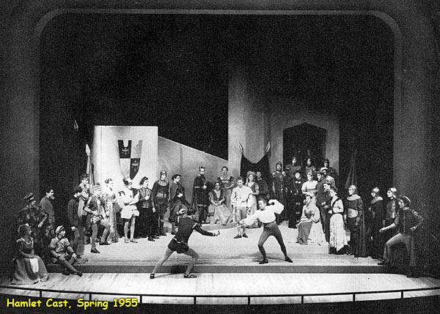
Reader’s Response
Entry #1
Act I

Directions
• Respond to 5 questions for this entry. Each response should be accompanied with at least 3-5 sentences of commentary and placed in your Readers Response Journal. Please follow the suggested format.

Act I: Scene I

- What is the setting of the play?

- What is Barnardo referring to when he says: “Last night of all, when some yond star that’s westward from ...”(9)?

- Characterize the ghost – who is it? why is it a ghost? what’s the purpose of the ghost’s appearance?

Act I: Scene II

- How is it that Claudius became king of Denmark?

- What part does Fortinbras of Norway play in this story?

- Who is Laertes and what part does he play in the events of the story?

- King Claudius asks of Hamlet: “How is it that the clouds still hang on you ...”(25). What is the answer to this question?

- In response to the previous question (question #7), Hamlet responds, “Not so my lord; I am too much in the sun”(25). Analyze and interpret the double-entendre of “sun.”

- In Hamlets speech to his mother (25), why does he emphasize the word “seem?”

- In the king’s speech to Hamlet (27), what advice does he give Hamlet with regards to life and death?

- What exactly is Hamlet saying about his mother (33-37)?

Act I: Scene III

- What advice does Laertes give Ophelia with regards to Hamlet (39-41)

- What advice does Polonius give his daughter Ophelia with regards to Hamlet (47-49)?

Act I: Scene IV

- Hamlet poses many questions to his father. What are the answers to these questions: “I’ll thee ‘Hamlet’” ... (51)?

15. What does Marcellus mean when he says: “Something is rotten in the state of Denmark” (55)?

