The Earth, My Butt, and Other Big Round Things
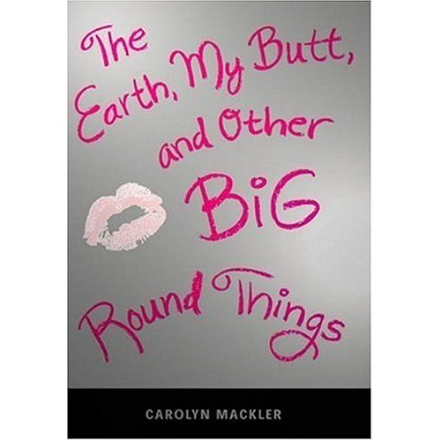

Reader’s Response Journal
Entry #7
Pages 192-246

Directions:
• Respond to 5 questions for this entry. Each response should be accompanied with at least 3-5 sentences of commentary and placed in your Readers Response Journal. Please follow the suggested format.

1. Analyze and interpret the source of Dr. Love’s regret – “When you were here for your last visit, I regretted involving her in that discussion” (194)

2. Explain the impulse that drives Virginia to type in to the student directory “A-N-N-I-E M-I-L-L-S” (196).

3. Analyze and interpret the following scene and its surrounding context from Virginia’s and Byron’s perspective: “Maybe it’s none of my fucking business, but I’m just saying that I’m probably about the only person who thinks you’re an asshole for date raping someone” (199)

4. With regards to Virginia going to Columbia to see Annie Mills, is she going out of spite for Byron or is some other emotion fueling her? Use the text to support your answer.

5. Analyze and interpret: “But as much as this has been a horrendous experience, my life isn’t wrecked. I won’t let him have that kind of power over me” (203)
a). What does Annie mean by this?
b). Why is it important that Virginia hear this message?

6. “I always thought Mom was the gatekeeper to my sister, that I couldn’t write her without mom’s permission. But Anais’s address has been here all along. I just had to look” (205)
a). How does this passage reflect Virginia’s transformation?
b). How do you suppose Anais will react to the letter?
c). What emotion fuels Virginia’s letter – spite, revenge, or something else?

7. Analyze and interpret: “I’ve enjoyed spending all of these lunch periods together, but I want to make sure you’re not isolating yourself from your peers. There are lots of nice kids at Brewster, if only you reached out, gave them a –“ (208)
a). Is this an act of betrayal? Explain
b). Is Virginia’s reaction justified? Explain

8. What ultimately prompts the following decision – “That’s when I decide to have a little hair appointment of my own” (211)?

9. In juxtaposing the following two scenes, explain the conflict between Virginia and her mother
a). “Special Effects had a particularly offensive shade called ‘Iguana Green.’ I kick myself for not going that route” (213)
b). “I’m taking time off to reevaluate my hair color. It’s hard always being a blond” (213).
10. How might the following statement serve as a turning point – “I wish I’d had the nerve to dye my hair purple when I was your age” (214)?

11. Based on pages 221-222, how is it that Virginia is developing a more mature outlook on life?

12. Analyze and interpret the fittingness of the following tribute: “Mr. moon, moon, bright and shiny moon, oh won’t you please shine down on me?” (225).

13. How might Virginia interpret the following passage by Virginia Woolf – “I thought at last that it was time to roll up the crumpled skin of the day, with its arguments and its impressions and its angers and its laughter, and cast it into the hedge” (226)?

14. Virginia’s webzine is discussed on pages 230-233. Why is this such an important endeavor for Virginia’s development?

15. To what extent is the dad’s gesture an insult – “Dad must have noticed the difference. Last Sunday we went to the Knick’s game together …” (237)?

16. On pages 239-240, Virginia shares her blog. How has she grown as a person if we compare these sentiments to who she was in the beginning of the novel?

17. Analyze and interpret the following gesture: “If you’re going to have facial jewelry, you shouldn’t wear silver, not with your complexion” (241).

18. Analyze and interpret the end scene on page 246. Why is kissing Froggy a triumphant moment for Virginia?

