The Earth, My Butt, and Other Big Round Things
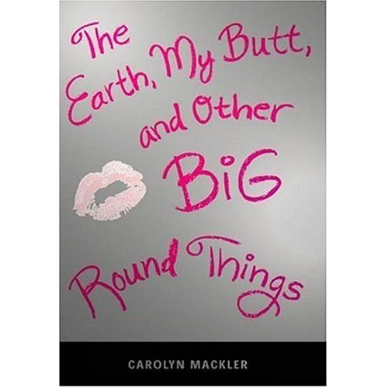

Reader’s Response Journal
Entry #6
Pages 150-191

Directions:
• Respond to 5 questions for this entry. Each response should be accompanied with at least 3-5 sentences of commentary and placed in your Readers Response Journal. Please follow the suggested format.

1. Analyze and interpret the following conflict: “Then again, she did say that if she looked like me, she’d kill herself. And I know from mom that if an eating disorder gets out of control, that’s exactly what can happen” (153).

2. Analyze and interpret: “I’m tempted to ask whether she means one of her teenagers or one of her problems” (155).

3. On page 156, Virginia is told by Joy Lassite that she is “lucky” to have Dr. Shreves as a mother. What is ironic about the comment and the interview exchanges on page 157?

4. Virginia left her mom’s interview and gets a hot cocoa. During her walk she recalls Ms. Crowley’s advice – “Don’t be so quick to doubt yourself” (159). Based on the context, what does this advice mean for Virginia?

5. Virginia’s mom angrily states ‘Where the fuck were you?’ (159).
a). What is mom really upset about?
b). To what extent does mom need to “swallow her own advice.”

6. An important turning point in Virginia’s life occurs on pages 160-161. Describe her transformation and the source of it.

7. In the end, Virginia goes to Seattle. Why is it significant that the mother never said she could go. Look at page 163.

8. On the ride to the airport, Virginia and her father make an important pact. Explain it and its importance.

9. Based on pages 166-167, compare and contrast the parenting methods of the Shreves and Malloy-Newman’s.

10. Analyze and interpret the various conflict as revealed in the “fairy godmother” discussion on pages 170-172.

11. With the letters that Froggy wrote to Virginia in mind, analyze and interpret the following passage: “I’m convinced that Froggy was legally blind in September but sold his trombone …” (173-174).

12. Based on page 175-177, why is it symbolically significant that Shannon wants to get her tongue pierced? Moreover, what does Virginia’s eye-ring signify?

13. Analyze and interpret Virginia’s epiphany about Froggy and the nature of relationships on page 179-180.

14. Juxtapose the conversation Virginia has with Liam and Nina on pages 178-179 to the car ride conversation Virginia has with her parents upon returning to NYC on pages 181-182.

15. What is significant about the following proclamation: “But now I now I couldn’t care less what Byron thinks” (182)?

16. Based on pages 183-184, how might Virginia’s eye-brow ring serve as a catalyst for change?

17. Although Dr. Shreves is the apparent expert of adolescent psychology, critique her parenting skills on pages 185-186 with regards to Virginia’s eyebrow ring.

18. With regards to the shopping outing with mom, pages 187-191, how is the event a battle for power?

19. Analyze and interpret Virginia’s eruption on pages 190-191
a). What prompts her anger and is her response justified?
b). Why is it ironic that “silent night” plays during this episode?

