Misery
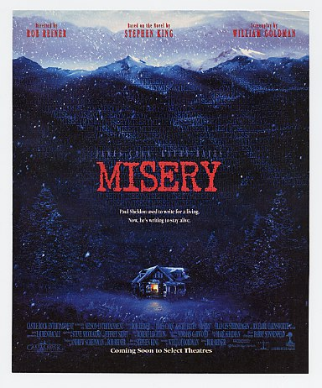
Reader’s Response
Entry # 5
Pages 148-182

Directions:
• Respond to 4 questions for this entry. Each response should be accompanied with at least 3-5 sentences of commentary and placed in your Readers Response Journal. Please follow the suggested format.

- Analyze and interpret Paul’s conflict with regard to the following scene: “On either side of the doorway, about eight inches up from the floor, was a black mark – they had been left, he understood at once by the hubs of the wheelchair when he found it though. So far she hadn’t noticed them. It had been almost a week, and her failure to notice was a small miracle. But soon – tomorrow, perhaps even this afternoon – she would be in to vacuum, and then she would” (150).

- Explain why Annie shackles Paul with handcuffs and gags him with a dust-rag. Use a quote to help support your answer.

- Analyze and interpret: “Well, he’s gone, Paul thought. Mr. Rancho Grande is gone but I’m here. Oh yes, I’m here” (154).

- Explain the context surrounding Paul’s comment – “You did more than save my life, you know. You saved two lives – because without you, Misery would still be lying in her grave” (156-157).

- Based on the surrounding context, analyze and interpret Paul’s thought process: “Africa. That bird came from Africa. But you mustn’t cry for that bird, Paulie, because after awhile it forgot about …” (161-162)

- Paul uses the overdue tax notice as a ploy to get Annie out of the house. Why doesn’t he leave his room? Why doesn’t he try to escape? Use a quote to help support your answer.

- Unpack this loaded statement: “Then the rain came and things changed” (167).

- Analyze and interpret Annie’s behavioral reaction: “Then there was a sound. It was not repeated, but it was utterly distinctive. It was a slap. A damned hard one. And since he was in here on one side of the locked door and she was out there on the other side of it, you didn’t have to be Sherlock Holmes to figure out that she’d slapped herself. Good and hard from the sound. He saw her pulling her lip out, digging her short nails into its sensitive pink meat” (169).

- Based on Annie’s comments, what are the symbolic correlations between the rat and Paul – “How its heart beats! How it struggles to get away! As we do, Paul! As we do. We think we know so much, but we really don’t know any more than a rat in a trap – a rat with a broken back that thinks it still wants to live” (173).

- Analyze and interpret: “Let me offer again, Paul. I can get my gun. I can end all of this for both of us. You are not a stupid man. You know I can never let you leave here. You’ve known that for some time, haven’t you?” (174).

- Analyze and interpret: “Going to her Laughing Place,’ Paul croaked and began to laugh to himself. She had hers; he was already in his. The wild gales of mirth ended when he looked at the mangled body of the rat in the corner” (176).

- Paul recollects a conversation he had with a man in a bar: “Bernstein’s answer had struck him as frivolous and cruel and incomprehensible: most of them had pianos. We Jews are very partial to the piano. When you own a piano, it’s harder to think about moving” (177). How does this recollection relate to his current predicament?

- What prompts Paul’s reaction: “You fucking bitch!’ He struck his fist against the side of the door. It hurt and he pressed the side of his hand against his mouth. He hated …” (180)?

- Annie leaves for her “Laughing Place.” Why doesn’t Paul escape to safety? Use a quote to help support your answer.

- Like in the classic cartoons, Paul is having a good angel, bad angel scenario play-out in his conscience. Explain the conflict based on the following scene: “I will never give up,’ he whispered. ‘Do you hear me? Never.’ Oh no? the voice of the cynic whispered sardonically. We’ll … see, won’t we? Yes. They would see” (182).

