The Absolutely True Diary of a Part-Time Indian
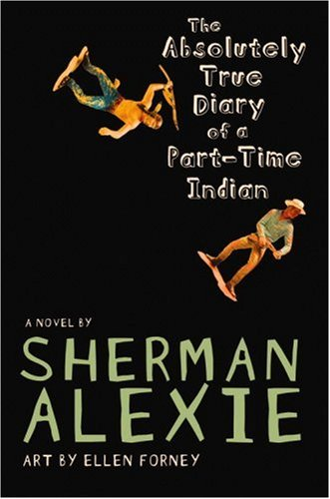
Reader’s Response Journal
Entry #4
Pages 130-178

Directions:
• Respond to 5 questions for this entry. Each response should be accompanied with at least 3-5 sentences of commentary and placed in your Readers Response Journal. Please follow the suggested format.

1. Explain the thinking that underlies the following statement: “I know, I know, but some Indians think you have to act white to make your life better. Some Indians think you become white if you try to make your life better, if you become successful” (131).

2. Analyze and interpret the metaphor of the apple on pages 131-132

3. Analyze and interpret Gordy’s notion of what community is on page 132

4. With regards to the story about the drinking fountain and his parents, how does the “you have to dream big to get big” concept apply to Junior?

5. With regards to pages 140-141 (Junior’s Basketball tryout versus Roger), who has the most hope?

6. Analyze and interpret: “The rez basketball fans were chanting, “Ar-nold sucks! Ar-nold sucks! Ar-nold sucks!’ They weren’t calling me by my rez name, Junior. Nope, they were calling me by my Reardan name” (143)

7. With regards to the basketball game on pages 144-149, what is Alexie suggesting about the importance of race?

8. Regarding the Christmas present his father gave him, Junior says that “It was a beautiful and ugly thing” (151). Explain what he means by this.

9. From Junior’s perspective, analyze and interpret the following line – “I’ve learned that the worst thing a parent can do is ignore their children” (153) and “I’ve learned that white people, especially fathers, are good at hiding in plain sight” (153).

10. Explain the following perspective – “Gay people were seen as magical, too” (155).

11. Analyze and interpret the implications of the following line: “I think all of us are always five years old in the presence and absence of our parents” (157).

12. Examine the irony of the following statement: “Drinking would shut down my seeing and my learning and my feeling. Why would I want to be in the world if I couldn’t touch the world with all of my senses intact” (158)

13. Analyze and interpret the ironic circumstances surrounding the following line: “Yep, even billionaires have Dark Nights of the Soul” (164).

14. With regards to the shooting death of Eugene, consider one of our essential questions - To what extent are tragedy and privilege congenital traits?

15. Concerning grief and its origins, how does Medea resolve Junior’s quandary?

16. Analyze and interpret: “It was like my friends had walked over the backs of baby seals in order to get to the beach where they could protest against the slaughter of baby seals” (176)

17. Analyze and interpret: “I want to think the world was broken down by tribes. By black and white. By Indian and white. But I know that isn’t true. The world is only broken into two tribes: the people who are assholes and the people who are not” (176)

