Misery
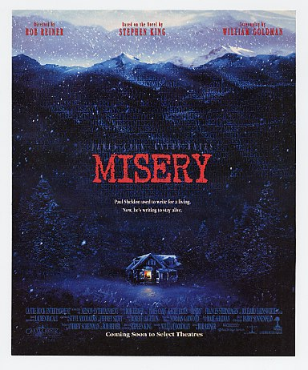
Reader’s Response
Entry # 4
Pages 91-148

Directions:
• Respond to 4 questions for this entry. Each response should be accompanied with at least 3-5 sentences of commentary and placed in your Readers Response Journal. Please follow the suggested format.

- Analyze and interpret the context surrounding the following passage: “It was as the door was swinging open that he looked down and saw that by looking for individual tracks with such agonized concentration, he had ignored a whole buffalo run: the boxes of Novril were still in his lap” (94).

- Pick apart Paul’s conflict in the following scene: “He began to cry. It was guilt he cried from, and he hated that most of all: in addition to everything else that this monstrous woman had done to him, she had made him feel guilty as well. So he cried from guilt … but also from simple childish weariness” (95).

- Analyze and interpret Paul’s conflict and the plot sequence in the following passage: “He shoved the last under the mattress, then leaned back and looked up at the ceiling, where the W’s danced drunkenly across the plaster. Africa, he thought” (97).

- Part II commences with the following quote from Montaigne – “Writing does not cause misery, it is born of misery.” How does this statement to the events in the book so far?

- In his first draft of Misery’s Return, how does Paul “return” Misery? Use a quote to help support your answer.

- Upon reading the first three pages of Misery’s Return, Annie replies – “It’s not right” (105). What isn’t “right” about Paul’s draft? Use a quote to help support your answer.

- To himself, since he doesn’t want to anger Annie, Paul criticizes Annie’s objection to his draft of Misery’s Return. He refers to “dues ex machine” on page 108. What does it mean and why is Paul referring to it?

- Based on pages 110-111, what is the significance of Rocket Man for Annie?

- Paul ponders writing a note to his old editor saying – “…Chris old buddy, but you also torpedoed me more than once, as you well know. Anyway, I just wanted to tell you to go ahead and do your worst – I’ve discovered a whole new critical mode, my friend. We might call it the Colorado Barbeque and the Floor Bucket school of thought. It makes the stuff you guys do look about as scary as a ride on the Central Park carousel” (115).
  - What is Paul really saying about Annie as an editor of his writing?
  - Paul references two past events. Explain each in relation to his comparison to Chris’s editorial style versus Annie’s.

- We continually have references to the following analogy: “The plane was in a power dive. He was searching for the parachute under the seat. Okay? Fair enough” (116). Explain this analogy and its relevance to the story.

11. Based on Paul’s second revision of Misery’s Return, how do you suppose Annie will react to it? Support your answer with direct textual references.

