Hard Love
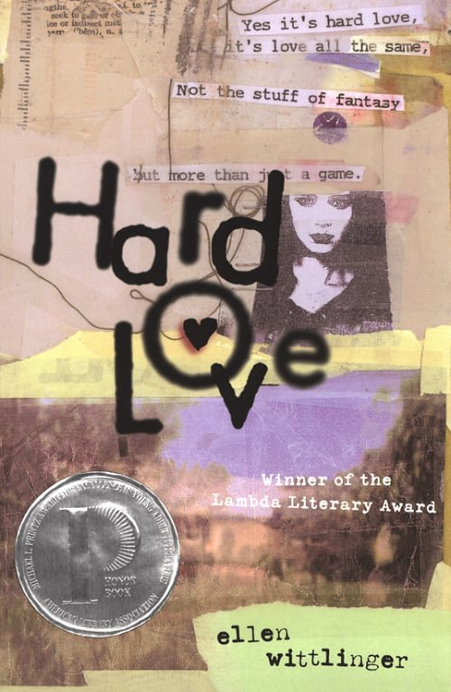

Reader’s Response Journal
Entry #4
Pages 155-End

Directions:
• Respond to 5 questions for this entry. Each response should be accompanied with at least 3-5 sentences of commentary and placed in your Readers Response Journal. Please follow the suggested format.

1. Analyze and interpret the underlying conflict in the following exchange:
John: “I wasn’t really sure what it meant”
Marisol: “Then you’re still not listening” (159)

2. Analyze and interpret: “I convinced myself a miracle had occurred: Marisol wanted to be with me the way I was suddenly willing to admit I wanted to be with her” (160).

3. Analyze and interpret: “This is what I’m talking about! You don’t listen to me! We had a nice thing, a good feeling. We broke through something with each other, but you want to make it something it’s not” (161). According to Marisol, what is the something she broke through with Gio?

4. Critique John’s comment: “If you didn’t want me to think of you as my date, you shouldn’t have shown up looking like that” (163).

5. Critique and interpret John’s argument and its relevance: “Something was there! Now you’re lying. We solved the ‘initial mystery’ – that’s what you said” (165).

6. Explain the following heterosexist questions by Brian: “Just because you tried to kiss her? I mean, it wouldn’t kill her, would it? She’s not allegoric to men, is she? (170).

7. The opening line of the book is “I am immune to emotion.” Explain the irony of this comment with regards to pages 170-171.

8. How just is John’s mother in saying – “You talk about your father’s selfishness, but it seems you’ve inherited more than just his good looks” (173)?

9. Analyze and interpret the double-entendre implied in the following line: “Fine. You clean it up. You’re the one who couldn’t hold on” (174).

10. John’s mother says “you’re a glutton for punishment” (175). To what extent does this statement come true when John accepts Marisol’s invitation to the zine conference on Cape Cod?

11. On pages 181-182, John and his mother seem to make some headway with their “talk.” Why, then, does John decide to leave the letter for his mother?

12. Analyze and interpret what Marisol means: “There are different ways to tell the truth, Gio. If you care about people …” (184)

13. Explain the source of John’s steadfast and stubborn oblivion – “There was nothing I want more, and probably nothing she wanted less” (189).

14. Analyze and interpret the irony and conflict in the following line: “I guess I wanted Marisol to see me with somebody else, see me having a good time without her. Except she wasn’t paying any attention” (194).

15. With regards to page 196, how does John’s playing of the jealousy card backfire on him?

16. Analyze and interpret “the point” from both the perspectives of Marisol and John: “Besides, she was just trying to make a point, wasn’t she” (203).

17. With regards to the poem on page 205
a). Analyze the double-entendre of “lying”
b). What is John’s tone and why is it this way?

18. With regards to page 209, what is significant of Marisol’s use of “I” instead of “we?”

19. Explain Marisol’s sentiment: “I have to do this, Gio. I have to see who I am without my parents hovering over me. Or you” (210).

20. Diana sings a song entitled “Hard Love” on pages 212-213. Gio says, “it ssegued into something very much like my current messed up situation” (212). Through tight diction analysis, explain how and why.

21. On the bottom of page 214, John apologizes to his mother for the letter. What has changed for him? Defend your answer by referring directly to the text.

22. Explain John’s sentiment: “Mom, I’m sorry I sent you the letter, but I’m not sorry I sent one to him. I don’t care if I never see him again” (216).

23. Based on the following line and its surrounding circumstances, is John in love with Marisol or with the idea of being in love – “Seeing her like that, running, toward me, as if she was choosing me, really tore me up. I could have screamed. Why couldn’t that be the truth? (221)

