The Earth, My Butt, and Other Big Round Things
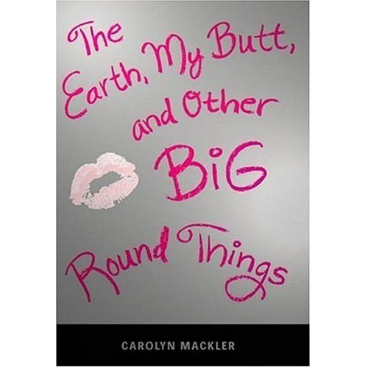

Reader’s Response Journal
Entry #4
Pages 80-109

Directions:
• Respond to 5 questions for this entry. Each response should be accompanied with at least 3-5 sentences of commentary and placed in your Readers Response Journal. Please follow the suggested format.

1. What impact, if any at all, do you think Ms. Crowley’s discussion about weight and dieting will have on Virginia (81-83)?

2. Compare and contrast Froggy’s note on page 86 to Virginia’s self-doubt on page 81.

3. Based on pages 87-88, argue that Froggy deems his relationship with Virginia to be more than casual.

4. With regards to Shannon’s letter on pages 91-92, how might this serve as a catalyst to impede Virginia’s diet?

5. There is an underlying implication in the following passage. Critique why it angers Virginia – “Mom and I will be in Connecticut all weekend, and I can’t let you go to Yankee stadium alone” (96).

6. Virginia says she won’t ask Froggy to the Yankee game because of The Fat Girl Code Conduct Rule #1: “No riding the moped in public” (96)
a). Would Froggy accept or reject the invitation? How do you know?
b). Unpack what rule #1 implies about Virginia’s weight?

7. Why does the phone call by Dr. Briggs knock Virginia off of her dieting bandwagon (98-99)?

8. Based on pages 98-100, what other impact does the news of Byron have on Virginia other than crashing her diet? What does this reveal about Virginia?

9. Shannon calls Virginia very early in the morning to share with her a quote on a box of Sleepy Time Tea: “When we try to pick out anything by itself, we find it hitched to everything in the universe” (103)
a). What does the quote mean?
b). How does it pertain to Virginia?

10. Analyze and interpret: “Diet tip #6: Do not discover that your beloved brother has been found guilty of date rape” (109). Does the date rape have anything to do with Virginia?

11. Why does Virginia avoid Byron when she returns home from the movies?

