The Absolutely True Diary of a Part-Time Indian
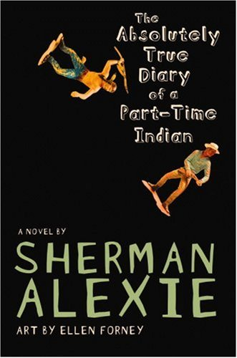
Reader’s Response Journal
Entry #3
Pages 82-129

Directions:
• Respond to 5 questions for this entry. Each response should be accompanied with at least 3-5 sentences of commentary and placed in your Readers Response Journal. Please follow the suggested format.

1. Examine the implications of the following statement: “Zitty and lonely, I woke up on the reservation as an Indian, and somewhere on the road to Reardan, I became something less than Indian” (83).

2. Based on page 89, consider the various angles that could explain Junior’s parents sense of failure.

3. Junior seems to hold a lot of respect for those that pursue their dreams. Why is it, then, that he has mixed emotions about his sister’s marriage and her impending life in Montana?

4. Analyze and interpret Gordy’s advice to Junior: “No, not at all. If you’re good at it, and you love it, and it helps you navigate the river of the world, then it can’t be wrong” (95).

5. Explain what Gordy means by the metaphorical boner of life.

6. According to the following line, what exactly has Gordy imparted to Junior – “He not only tutored me and challenged me, but he made me realize that hard work – the act of finishing, or completing, or accomplishing a task is joyous”

7. On page 102-103 Junior has a conflict between what he wants to say and what is actually said. Explain the source of this conflict and how it is resolved.

8. Analyze and interpret: “There are all kinds of addicts, I guess. We all have pain. And we all look for ways to make the pain go away. Penelope gorges on her pain and then throws it up and flushes it away. My dad drinks his pain away” (107).

9. On page 110 Junior surmises that Penelope is only dating him because he’s the “worst possible choice” and because he’s an Indian. Are these justifications accurate? Explain

10. Unpack the paradoxical irony of Junior’s statement to Penelope – “Why don’t you quit talking in dreams and tell me what you really want to do with your life” (111).

11. What do you think of Rowdy’s advice: “Hey, asshole. I’m sick of Indian guys who treat white women like bowling trophies. Get a life” (115)?

12. Analyze and interpret: “I think it means you’re just a racist asshole like everybody else” (116).

13. Based on pages 118-121, consider one of our essential questions – to extent is identity a part-time job?

14. What does the cartoon on page 120 suggest about the duplicitous nature of Junior’s identity?

15. Analyze and interpret the underlying conflicts in the following excerpt: “I figured she was going to march out of my life right then. But she didn’t. Instead she kissed me on the cheek. I guess poor guys don’t get kissed on the lips. I was going to yell at her for being shallow. But then I realized that she was being my friend. Being a really good friend, in fact. She was concerned about me. I’d been thinking about her breasts and she’d been thinking about my whole life. I was the shallow one” (127).

16. Analyze and interpret what racism has to do with the following admission: “And Roger, being of kind heart and generous pocket, and a little bit racist, drove me home that night” (129)

