The Earth, My Butt, and Other Big Round Things
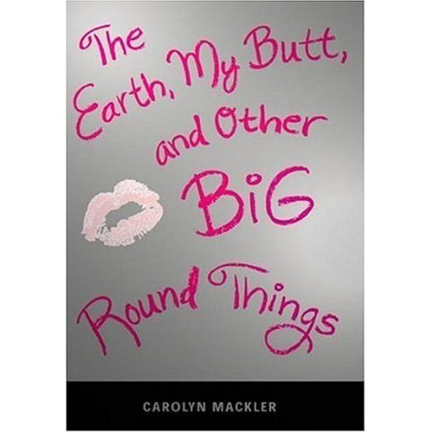

Reader’s Response Journal
Entry #3
Pages 47-79

Directions:
• Respond to 5 questions for this entry. Each response should be accompanied with at least 3-5 sentences of commentary and placed in your Readers Response Journal. Please follow the suggested format.

1. What does the following “Acceptance” reveal about Virginia – “Believe me, it would be nice to have a Shreves family meal every once in a while, but I’ve basically come to accept that’s not what my family is about” (48)?

2. Analyze and interpret Byron’s alleged reaction to Virginia’s weight gain. More importantly, is Virginia’s interpretation correct – “I choke up as the thought crosses my mind” (49).

3. Analyze and interpret the “smile” between Byron and friend in the following passage: “He smiles as he eyes me on Byron’s bed. Actually, not a smile. More of a male-binding grin. If there could be a facial expression that conveyed a thumbs-up sign, this would be it” (52).

4. On page 53-54, the Virgins & Sluts party is alluded to …
a). How does Virginia perceive this party?
b). How does Byron interpret this party?

5. What ultimately provokes V’s reaction: “By the time I reach the subway station, tears are trickling down my cheeks. I keep wiping them away, but every time I do, more slide out to replace them” (55)?

6. Analyze and interpret Virginia’s perception in the list she generated on page 56. Is she being overdramatic or is she seeing things as they are? Explain.

7. Analyze and interpret: “I wasn’t sure whether to be more taken aback that Mrs. Meyers confused me with my gorgeous sister or that she called Froggy my boyfriend” (59).

8. Analyze and interpret Virginia’s internal conflict in the following passage: “I’m going to get a shovel, dig a huge hole in Central Park, and crawl into it. I’ll pay someone to cover me up with dirt and put a stone on my grave that says: Virginia Shreves, 15, died from utter humiliation” (61).

9. On page 62, analyze and interpret the silence between Virginia and her mother. To what extent does Virginia’s mother own responsibility for her daughter’s low self-image?

10. How might the following line serve as an important turning point in the relationship of Virginia and her mother – “Every once in a while, I glance over at mom. I think I detect a tinge of pride on her face” (66)?

11. What impact does the following line have on Virginia – “You’ve got a great face, Ginny. Think how much prettier you could be if you lost 20 or 30 pounds” (67)?

12. On page 69, Virginia imagines herself as being thin. Based on this context, to what extent do others create her self-concept?

13. Analyze and interpret: “I’m spending my days in a constant state of peeing or starvation. But I know this will all be worth it. Besides, it’s not like I have any alternative.”
a). Is it worth it? Explain
b). Does Virginia have other alternatives? Explain

14. Virginia creates “The Food Police” on pages 72 -73. Based on her interaction with the media, is the media harming or helping Virginia?

15. On page 75, Virginia gets a present from her father. Critique this present from her father’s and Virginia’s perspective.

16. With regards to the “mirror scene” on pages 77-79 …
a). Why is Virginia pinching herself so hard?
b). Is she determined or defeated? Support your answer with the text.

