The First Part Last
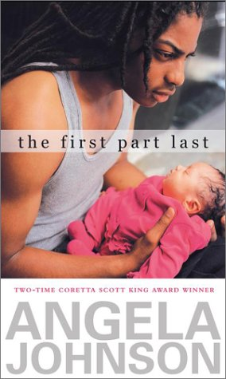

Reader’s Response Journal
Entry #2
Pages 23-49

Directions:
• Respond to 5 questions for this entry. Each response should be accompanied with at least 3-5 sentences of commentary and placed in your Readers Response Journal. Please follow the suggested format.

1. Structurally, the novel creates a conflict between the past (Then) and the present (Now). Analyze how this conflict manifests itself on pages 22-23.

2. Bobby wonders to himself about Dr. Victor – “…and by the way could she just write me a note and get me out of this? (25). What is it exactly that Bobby wants out of?

3. Why does the following comment anger Nia – “Yeah, I know you know directions, Nia – I’m just trying to do the right thing. Mary says … (27).

4. In the following excerpt, analyze and interpret “this”: This must be it. This must be what made my mom’s eyes narrow and nasty words come out of her mouth. This must be what helped …” (32).

5. Analyze and interpret the various conflicts at play in the following passage: “When I walk past my mom’s room, I miss her. I walk to my room, put Feather in her crib, which pisses her off and makes her scream, and then I look around my room and miss me” (35).

6. Analyze and interpret K-Boy’s and JL’s reaction to the news that Bobby will soon be a father on pages 36-37.

7. Answer the following questions from Bobby’s perspective – “What can I say? …What do you want us to say?” (38).

8. In the following passage, how does Bobby’s perspective and silence fuel his conflict: “My stomach is hurting by the time that question is out of my mouth and into the air. I don’t say; whatever I want, I can’t say. My dad already told me now was the time to shut my mouth. What Nia wants is what it’s all about” (40).

9. Tear apart the following line: “I could be telling her how she looks like her mom. And asking if she remembers her. It hasn’t been that long” (42).
a). Where is Nia?
b). What hasn’t been that long?

10. On pages 42-44, Bobby is approached by his English teacher
a). Explain Nia’s absence
b). Why isn’t Bobby answering fully and truthfully?
c). Why does Bobby act so negatively to his English teacher?

