The Earth, My Butt, and Other Big Round Things
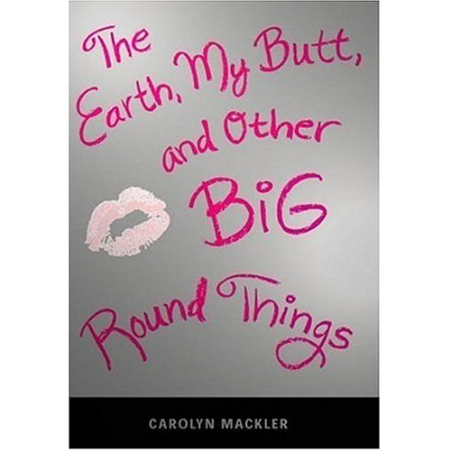

Reader’s Response Journal
Entry #2
Pages 21-46

Directions:
• Respond to 5 questions for this entry. Each response should be accompanied with at least 3-5 sentences of commentary and placed in your Readers Response Journal. Please follow the suggested format.

1. Of lunch at school, Virginia says – “This is the moment I most dread every day” (21). Why? Use direct textual references to support your claims.

2. On page 22, Virginia describes her “Back-Up Plan” for lunch.
a). Why does she need this plan and what is it?
b). How does her weight influence her plan?

3. On page 22, Virginia graphs her “Popular-Dorky chart.
a). What does the chart reveal about her self-image?
b). Where would you place her on the chart and why?
c). Virginia is only 3 points from “Regular.” Why?

4. Analyze the following equation that is on page 24 – (me = heavy; Shannon = stutter)

5. On pages 27-28, while Virginia hides in the bathroom stall, she overhears the conversation of The Queen Bee Popular Girls:
a). How might the suicide comment affect Virginia?
b). Analyze and interpret the source and cause of blood in Virginia’s mouth
c). How does the event further form a wedge between Virginia and her family?

6. Analyze and interpret the source of inequity in the following passage: “Dad hates wearing tuxedos, so mom is always bringing Byron to Black-tie events. She used to do the same with Anais. I keep hoping mom will invite me one of these days, but she hasn’t so far” (31).

7. To what extent does the following line pertain to Virginia’s relationship with her mom – “She wants to put as much distance as possible between her Ozark past and her Manhatten present” (34)?

8. On page 34, Virginia brings it up to her mom and she’s never been asked to attend a black-tie event. Immediately following this, mom says that Virginia will see a new doctor. Based on this exchange, consider the following:
a). Why hasn’t Virginia been asked to attend?
b). To what extent does the exchange “echo” the conversation of the “3 Bs” in
the bathroom?

9. On page 35, we find Virginia yet again escaping the hardships of her life by idly thumbing through magazines. How might these magazines perpetuate her self-conflict?

10. What is Virginia’s dad communicating to Virginia in the following scene: “We’ve polished off all the pastries when a beer commercial comes on. A woman in microscopic shorts and a bikini top parades around the baseball diamond. Dad whistles – ‘Now there’s an attractive woman’” (37)?

11. Analyze and interpret the conflicts in the following email sent to Shannon – “Did you know that ‘fat’ in French is ‘gros.’ If I didn’t hate French enough already, I hate it even more now. P.S. Byron was just being honest” (39).

12. Analyze and interpret: “But he’s managed to retain a database of songs in his head, songs that have our first names in them, songs that he delights in singing to mortified students” (40).
a). Mr. Mooney seems to be well-intentioned, but how do his intentions backfire
with Virginia?

13. Upon seeing Froggy in the computer lab, why are both of Virginia’s options “miserable, pathetic” (43)?

14. According to Virginia, what are the paradoxical criteria for being a Model Brewster Student (43-46)?

15. What might prompt Virginia to write “Virginia + Froggy” on a piece of paper (46)? Base your answer by referring directly to the text.

16. Analyze and interpret – “Because I can’t guarantee that if given the opportunity, I wouldn’t take Brie’s advice and go the way of my namesake” (46).

