The First Part Last
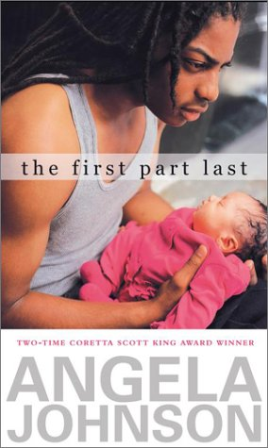

Reader’s Response Journal
Entry #1
Pages 1-22

Directions:
• Respond to 5 questions for this entry. Each response should be accompanied with at least 3-5 sentences of commentary and placed in your Readers Response Journal. Please follow the suggested format.

1. Bobby has a sudden epiphany – “Yeah. I get it now. I really get it.” (3). What does he “get?”

2. With regards to the following lines, analyze and interpret the “It” Bobby is referring to – “It made me cry like I hadn’t since I was a kid. It scared the hell of me.” (4).

3. Bobby proclaims, “Things have to change” (4). Within the context of the statement, why must things change?

4. Analyze and interpret what Bobby is saying: “But I figure if the world were really right, humans would live life backward and do the first part last. They’d be all knowing in the beginning and innocent in the end” (4).

5. Each chapter, in terms of the narrative structure of the book, begins with “Now” or “Then.” Why?

6. The first “Then” chapter references Bobby’s 16th birthday. Using a direct textual reference, how did this day serve as a turning point for Bobby’s life?
7. Bobby tells us “[He] used to laugh when the old dude, ‘Just Frank’ from the corner, used to ask [him] if [he] was being a ‘man.’ (7)
a) What does this question mean in the “Now” and “Then” of Bobby’s life?
b) Is Bobby being a ‘man?’
c) ‘Just Frank’s’ life taught Bobby some lessons. What are they?

8. On page 8 Bobby’s mom keeps warning “you’ll pay.” Analyze and interpret the irony of the warning with reference to Bobby’s thought: “I wonder if somebody threatened her that one day I’d love her and want to be with her all the time. Some threat” (8).

9. Analyze and interpret K-boy’s perspective and what it is exactly that makes Bobby crazy: “Everything is different if there ain’t no love. Didn’t want to hear that then. And I guess I don’t want to hear it now. He’s one of my best friends, but he’s always saying stuff that makes me crazy” (10).

10. Analyze and interpret the conflict in the following exchange between K-Boy and Bobby: “It’s a stupid fucking question. What’s the problem” (11).

11. Critique Bobby’s parent’s reaction to his news that Nia is pregnant on pages 12-13.

12. What is so important about the “knowing” in the following passage: “But then I realize. I’ve done it. I know something. I know something about this little thing that is my baby. I know that she needs me. I know what she does when she just needs me” (15).

13. At times Bobby appears to be strong, yet, as is the case in the following passage, he is very fragile. Based on the following excerpt, what provokes his fragility – “I have to lean against the sides ‘cause I could break down any minute. Just fall apart anytime …” (17).

14. On pages 20-21, Bobby recounts the day Nia’s parents learned about the pregnancy. Compare and contrast what Bobby utters aloud and what is spoken in his mind.

