Hamlet
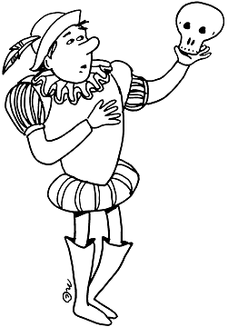
Question #2

(Suggested time – 40 minutes)

☺ In Act III Scene 1 Ophelia and Hamlet have an exchange with regards to their relationship. Analyze the tone of each character, their attitudes and choice of diction. Make sure you identify the purpose and methods used to accomplish each characters rhetorical purpose.

Ophelia: Could beauty, my lord, have better commerce than with honesty?

Hamlet: Ay, truly, for the power of beauty will sooner transform honesty from what it is to a bawd than the force of honesty can translate beauty into his likeness. This was sometime a paradox, but now the time gives it proof. I did love you once.

Ophelia: Indeed, my lord, you made me believe so.

Hamlet: You should not have believed me, for virtue cannot so [inoculate] our old stock but we shall relish of it. I loved you not.

Ophelia: I was the more deceived.

Hamlet: Get thee to a nunnery. Why wouldst thou be a breeder of sinners? I am myself indifferent honest, but yet I could accuse me of such things that it were better my mother had not borne me: I am very proud, revengeful, ambitious, with more offenses at my beck than I have thoughts to put them in, imagination to give them shape, or time to act them in. What should such fellows as I do crawling between earth and heaven? We are arrant knaves all; believe none of us. Go thy way to a nunnery. Where’s your father?

Ophelia: At home, my lord.

Hamlet: Let the doors be shut upon him he may play the fool nowhere but in his own house. Farewell.

Ophelia: O, help him, you sweet heavens!

Hamlet: If thou dost marry, I’ll give thee this plague for thy dowry: be thou as chaste as ice, as pure as snow, thou shalt not escape calumny. Get thee to a nunnery, farewell. Or if thou wilt needs marry, marry a fool, for wise men know well enough what monsters you make of them. To a nunnery, go, and quickly too. Farewell.

Ophelia: Heavenly powers, restore him!

Hamlet: I have heard of your paintings too, well enough. God hath given you one face, and you make yourselves another. You jig and amble, and you lisp’ you nickname God’s creatures and make your wantonness your ignorance. Go to, I’ll no more on’t. It hath made me mad. I say we will have no more marriage. Those that are married already, all but one, shall live. The rest shall keep as they are. To a nunnery, go.

