Hamlet
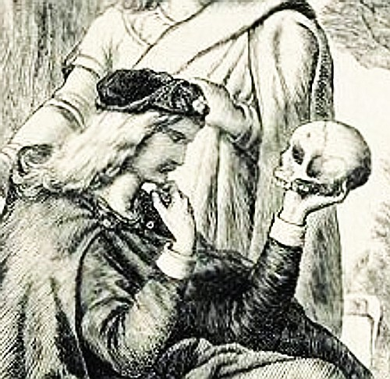
Question #2

(Suggested time – 40 minutes)

☺In Act 4 Scene 7 Gertrude details Ophelia’s death for Laertes. Analyze Gertrude’s tone, attitude, and choice of diction as she informs Laertes of the sad news. Make sure you identify her purpose and the methods she uses to accomplish that purpose.

Queen: One woe doth tread another’s heel,
So fast they follow. Your sister’s drowned, Laertes.

Laertes: Drown’d! O, where?

Queen: There is a willow grows aslant a brook,
That shows his hoary leaves in the glassy stream.
Therewith fantastic garlands did she make
Of crow-flowers, nettles, daisies, and long purples,
That liberal shepherds give a grosser name,
But our cold maids do dead men’s fingers call them.
There on the pendant boughs her crownet weeds
Clambering to hang, an envious sliver broke,
When down her weedy trophies and herself
Fell in the weeping broke. Her clothes spread wide
And, mermaid-like, awhile they bore her up;
Which time she chaunted snatches of old lauds,
As one incapable of her own distress,
Or like a creature native and indued
Unto that element; but long it could not be
Till that her garments, heavy with their drink,
Pull’d the poor wretch from her melodious lay
To muddy death.

