Poetic Seventh
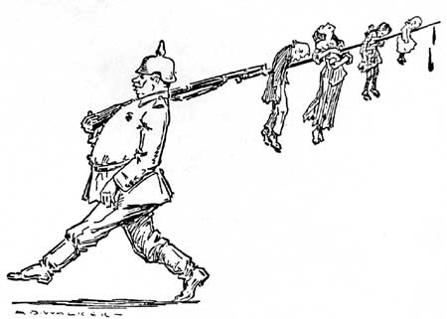

Controlling Idea Essay

Your Task:
Select two poems from this round of the Poetic Seventh and write a unified essay about the nature of war and loss. In your essay, use ideas from both passages to establish a controlling idea about the nature of war and loss. Using evidence from the passages, develop your controlling idea and show how the author uses specific literary elements or techniques to convey that idea.

POEMS
“Gift in Wartime” “Kill Me a Son”
“Facing It” “On Being Asked… ”
“Dead Weight” “The Long Black Wall”
“The Diameter of a Bomb”

Guidelines
- A concise introduction that unpacks & pertains to the nature of personal integrity as revealed in both poems

- One clearly phrased thesis statement that addresses the prompt

- A minimum of 4 direct textual references to support and defend your position

- Analysis of relevant literary terms: tone, diction, conflict, characterization, setting, plot, double-entendre, imagery, figurative/literal language, etc.

- Syllogistic analysis of each poem that proceeds stanza by stanza

- Sentence clarity, fluency, punctuation, organization

