Of Mice & Men
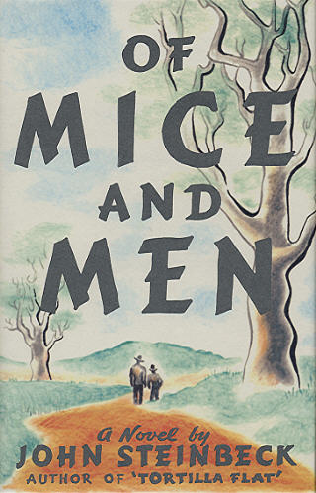

Chapter 1 Summary

Of Mice and Men opens with a physical description of the topography of the Central Valley of California. "A few miles south of Soledad," the Salinas river winds through an idyllic scene of yellow sands, golden foothills, and deer that come to the shore to drink at night. It is in this setting that we first meet Steinbeck's two protagonists, George Milton and Lennie Small. George is "small and quick, dark of face, with restless eyes and sharp, strong features." Lennie is "his opposite, a huge man, shapeless of face, with large, pale eyes, with wide, sloping shoulders." They have just come from the town of Weed in Northern California where Lennie had gotten into some sort of trouble, forcing them to flee south. There they are now looking for new work on a ranch. As.....

Chapter 2 Summary
It is about ten o'clock the next morning. The chapter begins with a description of the ranch's bunkhouse. It is a long building, with an unpainted floor, and eight bunks inside. Above each bunk is an apple box, where the men place their belongings. Lennie and George, having arrived at the ranch, enter the bunkhouse to see where they will be staying. An old man, who we later learn is named Candy, tells them that the boss was expecting them the night before and is very angry that they were not there to go to work in morning. George is disturbed to find a can of bug poison in his bed's box shelf, but the old man tells him that there are no bugs. The blacksmith who used the bed before George was.....

Chapter 3 Summary
At dusk, Slim and George return to the bunkhouse. They are talking about the puppy Slim has given Lennie. Slim comments that Lennie is not bright, but he is a very good worker, affirming George's earlier statement. He says he has never seen anyone so strong. Slim also comments on the unusual relationship between George and Lennie. George becomes defensive, but Slim does not mean any harm. He tells George that very few men travel together, and he calls Lennie cuckoo. George defends Lennie and says he may not be smart, but he is not crazy. George explains how he and Lennie have known each other since they were children. When Lennie's Aunt Clara died, Lennie began traveling with George. George tells Slim that he used to play jokes on Lennie. It was.....

Chapter 4 Summary
It is Saturday night as this chapter opens, and Crooks is sitting in his room. He lives in a small part of the harness room and sleeps in a straw filled box. Unlike the others, Crooks is a permanent part of the ranch. Therefore, he has accumulated more possessions than the others have, but he keeps his room neat. Crooks is rubbing liniment into his injured back. Lennie appears in the doorway and stands there, looking in. At first, the uninvited visitor angers Crooks. Lennie is only trying to be friendly. He says he was looking at his puppy and he saw Crooks' light on. Crooks tell him to leave. The older man says he is not allowed in the bunkhouse because he is black. Therefore, he will not let others in his.....

Chapter 5 Summary
On Sunday afternoon, Lennie is alone in the barn looking at a dead puppy. He pets the puppy and asks it why it died. He has bounced the dog too hard and killed it. He hides the dog in the hay so George will not find out. He is worried that he will not be able to tend the rabbits. Then he changes his mind and decides to tell George he found the puppy dead, so he unburies it. As he looks at the little dog, he realizes George will know he killed it. Lennie becomes angry at the dead animal. He yells at the dog and blames it for dying. He throws the puppy and begins to rock back and forth; he is afraid he will never be able to tend the.....

Chapter 6 Summary
It is late afternoon along the Salinas River, and the sun has started to set. Lennie walks out of the brush. He kneels down at the edge of the pool and drinks. He then sits on the bank and embraces his knees. Lennie speaks softly, saying that he did not forget and is hiding in the brush. He is worried that George is going to be angry and want to live alone. He says he will go off and live in a cave. From out of Lennie's head comes an old woman. The imaginary Aunt Clara scolds him for doing bad things. Lennie apologizes, saying he tried to behave. He again says he will go off into the hills and live in a cave, but Aunt Clara tells him that he will never.....

USEFUL 1ST PREMISES

* The disloyal killing of Candy’s dog foreshadows the culminating events at the novel’s end.

* Lennie’s is characterized as having hands like bear claws, which creates the central conflict of the book.

* Steinbeck’s use of repetition sets up the foreshadowing – through repeated killings and troubles (mice, puppy, incident in Weed, Curly’s hand) – it is easy to ascertain that Lennie will get into big trouble with his hands.

* The theme of loyalty is at play in the novel’s last scene

* The characterization of Lennie's hands being compared to bear claws is very significant.

* The scene when Lennie and George show up in Soledad looking for work foreshadows the killing of Lennie later on in the book.

* In the ending of the book George faces a great conflict with what he should do about Lennie.

