

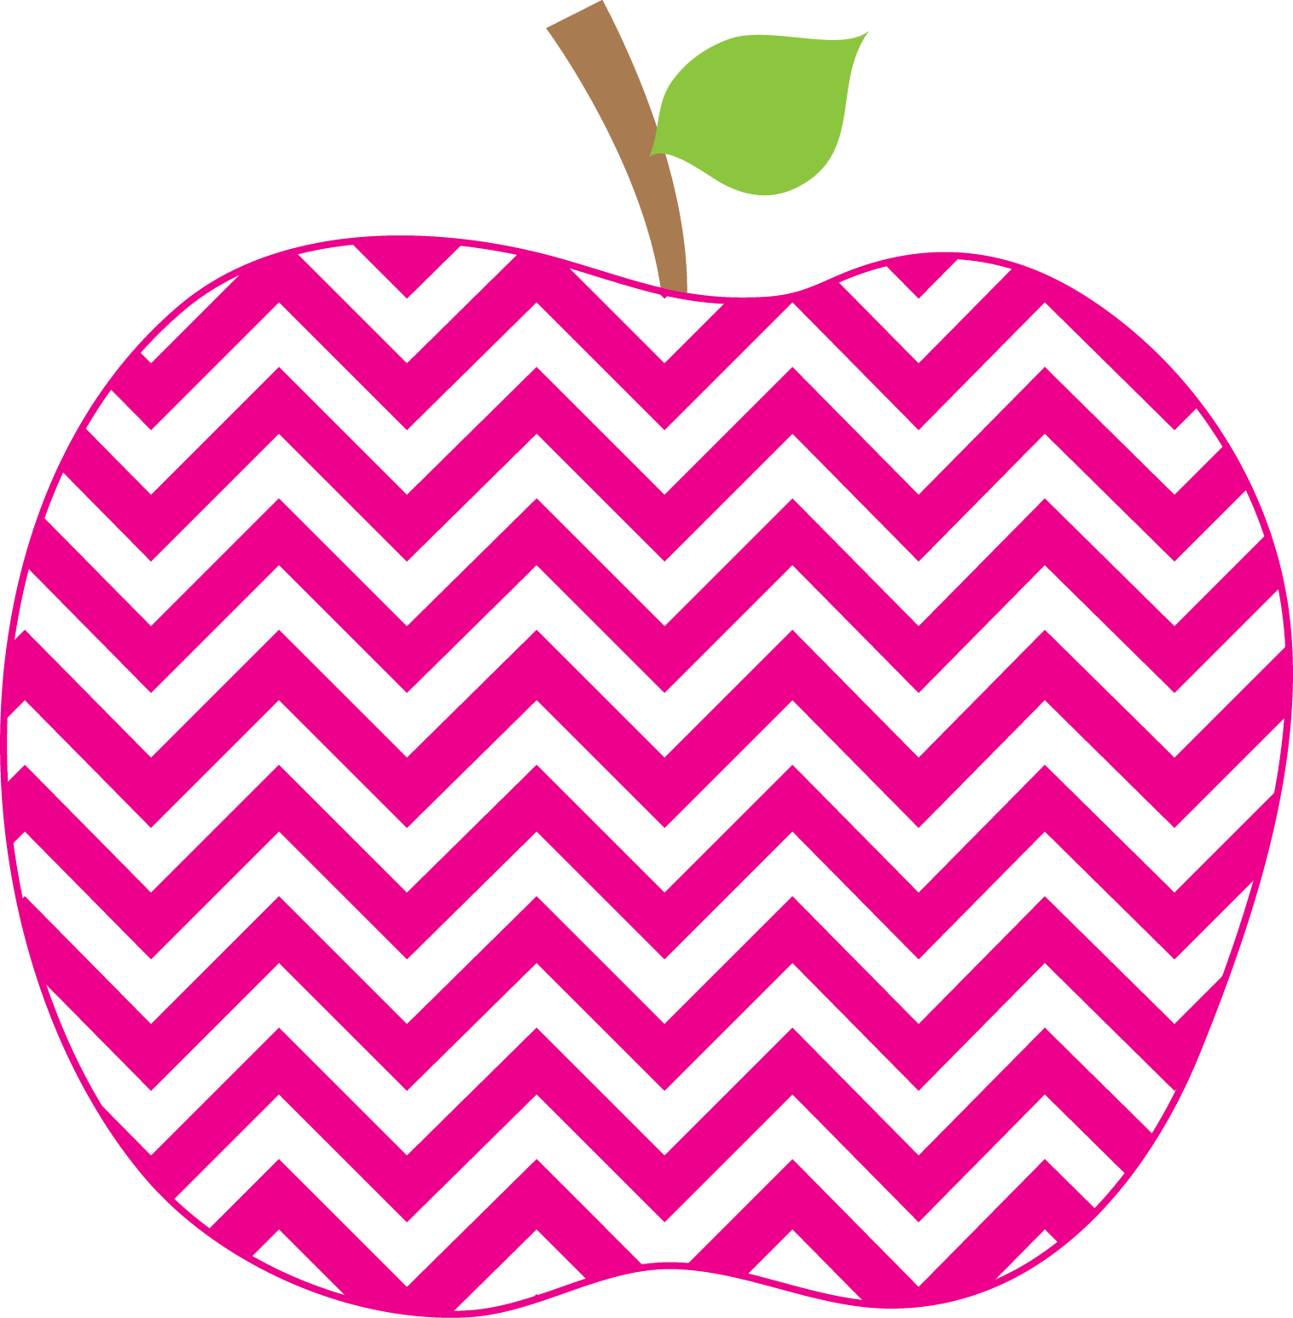



Weeks Weekly
The
October 4, 2018

We are continuing our practice of tapping to read and spell CVC (Consonant Vowel Consonant) words. This week we also began our work on trick words (same thing as sight words). Students are practicing on spelling them and on using a resource to help them.
In math, we have been working on identifying equivalent expressions. Some examples are 3+4 = 4+3 as well as 6+2 = 3+5. Sometimes we find some that are false, like
3+4 = 2+6, and then change one of the numbers to make it a true number sentence. This is some pretty impressive work for first graders!
In social studies we talked about rights and responsibilities. We shared responsibilities the students have at home and at school and we read a beautiful book called, I Have the Right to Be a Child by Aurelia Fronty.

Some other books we enjoyed this week were:
Who’s Who in a School Community
The Pigeon Finds a Hot Dog!

Please come to our Get Acquainted Night on Wednesday from 6:15-7:15! Please also use the shuttle bus that leaves from the Fire House on Bailey Road. We will be in the classroom to share our room and work with you. I will do a short presentation at 6:30. Email me if you have any questions! This is also the time to schedule our November Parent-Teacher conference!

--Kim Weeks
kweeks@rhnet.org
359-5413 x2483 (voicemail)

The Week in Review

A Look Ahead…

Tues. 10/9 D Day
Wednes. 10/10 A Day
Thurs. 10/11 B Day
Fri. 10/12 C Day

** Wednesday will be our “make-up” library day this week!**
Fri. 10/5 – NO SCHOOL (Superintendent’s Conference Day)
Mon. 10/8 – NO SCHOOL (Columbus Day)

Tues. 10/9 – Our class visits Book Fair (send in
money if you would like)
Wed. 10/10 – Get Acquainted Night 6:15-7:15 PM
(Book Fair Open 6-8 PM)
Thurs. 10/11 – Picture Day

ME = Meeting Expectations
NS = Needs Support
Respectful: _______
Responsible: _______
Ready to Learn: _______
Trustworthy: _______
Caring: _______

Parent Signature: ________________________
Important Dates!
PBIS: A Note on Behavior

