Laura Reed
Ms. Caldiero
Contemporary Literature ACE 3.3
6 October 2010
Peter Parker a.k.a. Spider-Man:
A Sacrificial Hero
Although many agree with newspaper editor J. Jonah Jamison that Spider-Man is a “no-good criminal who hides behind a mask,” in truth, Peter Parker is a hero who uses his masked identity to keep the streets of New York City safe despite the lack of recognition for his good deeds (216).
Spider-Man is a hero who serves the interests of others before his own. When Peter Parker first got his powers from a radioactive spider bite, he tried to use these powers to make money as a professional wrestler. However, his Uncle Ben’s tragic death made him realize an important principle: “With great power there must also come great responsibility” (Urich 24). Because he believed this, Peter dedicated his life to saving the lives of those in danger. He tirelessly fought everyone from small-time criminals to super villains (“Why Spider-Man”). He did not give up even when the Daily Bugle kept accusing him of being a criminal himself and a “serious threat to the city” that he loved and served (Jamison 218-220). Just like he first chose to give up trying to making money with his powers, Peter often made difficult sacrifices in his personal and academic life because of his work as Spider-Man, continually putting the safety of others above himself (“Why Spider-Man”).
As Ben Urich writes, “Like a true hero, Spider-Man does what he knows is right even when he does not receive the praise he deserves and when it requires great personal sacrifice” (25).

In-Text Citations:

Also see the paper above for examples of correct MLA in-text citation format.
*Quick Version of the MLA Rules: At the end of the sentence or section where you use the information, use parentheses to give the author’s last name and the page number where you found that piece of information: (Urich 24).
The period comes AFTER the end parentheses.
Note: There is NO COMMA between the author’s last name and the page number.

Common Variations:
(1) If there is no author’s name given, use the first word or the first few words from the title of the title in quotation marks: (“Investigation” 68) or (“Peter Parker Charged”).
(2) If there are no page numbers, don’t make one up—just don’t put one down.
(3) If the information comes from more than one page or paragraph, use a hyphen to indicate the start and end pages: (Andrews 12-14). Also, the page numbers that printer assigns to the number of pages it is printing are NOT usable.
(4) If you use the author’s name in the “signal phrase” (somewhere in the sentence itself attributing the information to them), just put the page number in the end parentheses.
(5) If there are two or more authors, put up to three in parentheses with “and” and commas: (Smith, Green, and Jones 213-215).
(6) If the same information came from MULTIPLE SOURCES, separate the citations with semicolons: (Smith 123; Andrews 16-18; “Federal”).
*For more specifics on in-text citations and work cited examples, visit http://www.dianahacker.com/resdoc/ and look under Humanities—Documenting Sources

MLA Paper Formatting:
General: Entire paper needs to be double spaced, with one-inch margines, aligned left. First sentence of each paragraph should be indented 5 spaces (1 Tab).

Heading:
Your name
Teacher’s name
Class title
Date paper is DUE, formatted Day Month (written out) Year, with NO commas in between (see first page for example).
The tile of the paper is centered. If there is a subtitle, put a colon after the main title and put the subtitle on a separate line (see first page for example).
Margins: Margins must be 1 inch all the way around. They are not like this automatically!
Go to File>Page Setup and make sure the Margins for Top, Bottom, Right, and Left all are at 1”.

Headers: MLA requires that you put your last name and the page number in a header (go to Insert—Header). Click on Page Number choose Top of Page on the Upper Right. Tab over twice, type name, and leave 1 space between name and page number.

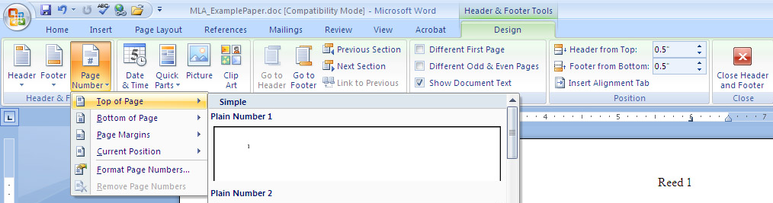

Long Quotations: Quotes that are more then four lines must be indented TEN Spaces from the left (to the number 1 on the top ruler). To do this, highlight the whole quote and hit the Tab key twice. When indented, no quotation marks are need. No extra line space is needed after the quote.

Paraphrasing:

Quote: “Spider-Man is a menace to society, and people need to recognize that. You cannot trust a person who hides their face behind a mask. People who honestly want to do good in this world would feel free to stand before the world” (Jamison 143).
Paraphrase: J. Johan Jamison tired to convince the public that Spider-Man was not trustworthy and did not have good intentions because he would not show the world his true identity (143).
Work Cited
Jamison, J. Jonah. Spider-Man: The Truth About the Mask Menace. New York: Random House, 2003.
Urich, Ben. “Peter Parker: Co-Worker, Friend, and Hero.” Journal of Super-Hero Happenings 12.4 (2006): 23-27. Student Resource Center Gold. Gale. Rush-Henrietta SHS Lib., NY. 1 Mar. 2008 <http://web.ebscohost.com>.
“Why Spider-Man is Good for New York City.” 2004. NYC News Source. 1 Mar. 2007 <http://www.nycnewssource.com/super-heros/spider-man>.

Red=Author, Pages, and beginning of Title (What goes in the in-text citations).
Purple=Title info
Green=Publication and source info
Blue=Access and location info
Tip for Indentation: Put your cursor at the top of the Work Cited page and drag the bottom arrow on the ruler bar so that it is 5 spaces in (Hanging Indent). If you don’t see the rulers, make sure Word is in View— Print Layout.
