Hamlet & The Lion King
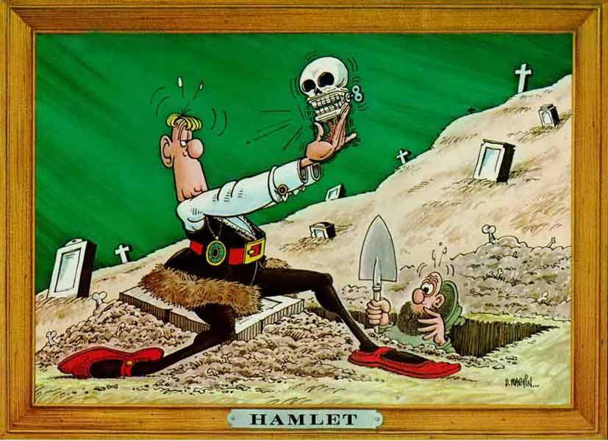
a cross-textual analysis

Assignment Overview
☺There is no doubt that today's entertainment has lost most of its touch with the more classical influences of its predecessors. However, in mid-1994, Walt Disney Pictures released what could arguably be the best animated feature of all time in The Lion King. With a moral base unlike most of the movies released at the time, The Lion King places a children's facade on a very serious story of responsibility and revenge. However, this theme is one of the oldest in history, and it is not the least apparent in one of the oldest works of literature by The Bard himself, William Shakespeare. The work that Disney's The Lion King parallels is none other than Hamlet: Prince of Denmark, and the film shadows this work so closely, that parallels between the main characters themselves are wildly apparent. This very close comparison has led critics "to compare the movie to Hamlet in the importance of its themes" (Schwalm 1). But with a closer inspection of the characters themselves do we see just how apparent these similarities are.
For this paper I want you consider:
□ Aristotle’s assertion that all art is imitation
□ Similarities in plot, theme, characterization, diction, and setting between both texts
□ The role of the tragic figure and the element of tragedy itself

