Rush-Henrietta High School
11R English Research Project
Handbook
Table of Contents
Introduction |  |  |  |  |  |  |  |  |  | 1
Database Access and Passwords |  |  |  |  |  |  |  |  |  | 2
Beginning the Research Process |  |  |  |  |  |  |  |  |  | 3
Plagiarism |  |  |  |  |  |  |  |  |  | 5
MLA Sample Research Paper |  |  |  |  |  |  |  |  |  | 7
Works Cited Format |  |  |  |  |  |  |  |  |  | 14
Research Writing Checklist |  |  |  |  |  |  |  |  |  | 15
Outlining |  |  |  |  |  |  |  |  |  | 16
The Thesis Statement |  |  |  |  |  |  |  |  |  | 17
Transitions |  |  |  |  |  |  |  |  |  | 18
Use of Quotations |  |  |  |  |  |  |  |  |  | 20

Introduction

What is scholarly research?

We undertake research when we wish to explore an idea, probe an issue, solve a problem, or make an argument that compels us to turn to outside help. We then seek out, investigate, and use materials beyond our personal resources. The findings and conclusions of such an inquiry appear in the research paper (Gibalidi 2).

What are primary and secondary sources?

The research paper is generally based on primary research, secondary research, or a combination of the two. Primary research is the study of a subject through firsthand observation and investigation, such as analyzing a literary or historical text, a film, or a performance; conducting a survey or an interview; or carrying out a laboratory experiment. Primary sources include statistical data, historical documents, and works of literature or art. Secondary research is the examination of studies that other researchers have made of a subject. Examples of secondary sources are books and articles about political issues, historical events, scientific debates, or literary works (Gibaldi 2).

Where does the student’s voice fit in?

Research increases your knowledge and understanding of a subject. Sometimes research will confirm your ideas and opinions; sometimes it will challenge and modify them. But almost always it will help to shape your thinking. Unless your instructor specifically directs you otherwise, a research paper should not merely review publications and extract a series of quotations from them. Rather, you should look for sources that provide new information, that helpfully survey the various positions already taken on a specific subject, that lend authority to your viewpoint, that expand or nuance your ideas, that offer methods or modes of thought you can apply to new data or subjects, or that furnish negative examples against which you wish to argue. As you use and scrupulously acknowledge sources, however, always remember that the main purpose of doing research is not to summarize the work of others, but to assimilate and to build on it and to arrive at your own understanding of the subject (Gibaldi 3).

Source: Gibaldi, Joseph. MLA Handbook for Writers of Research Papers, sixth edition. New York: The Modern Language Association of America, 2003.
Database Access and Passwords
All of these databases are fully accessible from home. To access, go to rhnet.org, select Schools>Senior High School, and then click on SHS Library from the left-hand menu.

Gale Databases  http://infotrac.galegroup.com/galenet/nysl_ro_rush  Username: *NONE*  Password: empirelink  Contains:  - eBooks  - Student Resource Center Gold  - Biography Resource Center  - Opposing Viewpoints  - Health and Wellness Resource Center  - Business and Company Resource Center  - National Newspapers  - New York Newspapers | ProQuest  http://proquest.umi.com/login  Username: W6PB4CFNP8  Password: welcome  - A multidisciplinary resource including ProQuest Research Library with citations and abstracts for over 2,500 journals, magazines, and newspapers, many dating back to 1986 or earlier and covering all subject areas.
CQ Researcher  http://library.cqpress.com/cqresearcher  Username: rush10  Password: cqel  - CQ Researcher is noted for its in-depth, unbiased coverage of health, social trends, criminal justice, international affairs, education, the environment, technology, and the economy. | Grolier Encyclopedia http://go-passport.grolier.com/  Username: nystate1478  Password: novelhome  - Like Wikipedia? Here’s an online encyclopedia that written by professionals. It’s a great place to start your research with an overview of the topic.
Noodletools  http://www.noodletools.com  School Username: rh-shs  Password: rhcsd  *Once you create and account, your Username and Password should be just like your computer login.  - Noodletools is “the Web's most comprehensive and accurate MLA, APA, and Chicago/Turabian bibliography composer with fully-integrated note-taking." | EBSCOHost  http://search.ebscohost.com  Password: rhebsco  *Choose EBSCOWeb and “select all” to search all the EBSCO databases at one time.  Contains:  - Primary Search  - Funk & Wagnalls New World Encyclopedia  - Teacher Reference Center  - GreenFILE (environmental research)  - Advanced Placement Source  - Psychology & Behavioral Sciences Collection
Beginning the Research Process
Chosen Topic – Thesis Statement:
__________________________________________________________________________________________
__________________________________________________________________________________________
__________________________________________________________________________________________
__________________________________________________________________________________________

List terms (keywords and phrases) you might use to search topic to locate desired results.
(List both broader and narrower terms and related synonyms (similar words))
___________________________ ___________________________ ___________________________
___________________________ ___________________________ ___________________________
___________________________ ___________________________ ___________________________
___________________________ ___________________________ ___________________________
___________________________ ___________________________ ___________________________
Research Tips
- Listen to reference instruction in library carefully.
- Select databases and resources that may be helpful for your topic during this instruction.
- Combine keywords to broaden or narrow results.
- Databases assume combined keywords mean AND or all words must be found. Use “Advanced Search” to combine similar keywords using OR.
- Use quotes (“ ”) around phrases (in some databases – use advanced search tools in others) to return more focused, accurate results.
- Choose “subject” to narrow or “entire document” to expand search instead of “keyword” in some databases.
- Save time by selecting “full text” option to return complete articles only.
- Take advantage of tools on top or sides of database page to broaden or narrow results being returned.

- Remember to check tabs on top to move between magazine, newspapers, journals, and other sources.
RH Database Tips ’09-‘10
- Remember: a subscription database is a collection of published and, therefore credible, articles.
- Not all databases are created equal. While it is possible, occasionally, to find the same article in two or more databases, it is more likely to find different selections in each database we offer.
- Broad, general information is available in Grolier Encyclopedia and, for issues of public importance, CQ Researcher.
- General magazine and journal databases are Gale Student Resource Center, Ebsco (select all), and ProQuest. Check all for different results!
- Great Pro-Con articles are highlighted in Gale Opposing Viewpoints and CQ Researcher.
- Biography Resource Center from Gale is great source for biographical information
- Alexandria is a database of the great print resources we have in our library.

Beginning the Research Process
Chosen Topic – Thesis Statement:

Teen curfews, which are designed to force teens out of malls and off of streets, punish
all for the actions of a few, violate the first and fourteenth amendments of adolescents,
and would no longer be necessary if teens had alternative activities to occupy their time.

List terms (keywords and phrases) you might use to search topic to locate desired results.
(List both broader and narrower terms and related synonyms (similar words))
teenager |  | town |  | curfew
teen |  | city |  | law
adolescent |  | mall |  | amendment
student |  | street |  | rights
youth |  |  |  | case

Research Tips
- Listen to reference instruction in library carefully.
- Select databases and resources that may be helpful for your topic during this instruction.
- Combine keywords to broaden or narrow results.
- Databases assume combined keywords mean AND or all words must be found. Use “Advanced Search” to combine similar keywords using OR.
- Use quotes (“ ”) around phrases (in some databases – use advanced search tools in others) to return more focused, accurate results.
- Choose “subject” to narrow or “entire document” to expand search instead of “keyword” in some databases.
- Save time by selecting “full text” option to return complete articles only.
- Take advantage of tools on top or sides of database page to broaden or narrow results being returned.

- Remember to check tabs on top to move between magazine, newspapers, journals, and other sources.
RH Database Tips ’09-‘10
- Remember: a subscription database is a collection of published and, therefore credible, articles.
- Not all databases are created equal. While it is possible, occasionally, to find the same article in two or more databases, it is more likely to find different selections in each database we offer.
- Broad, general information is available in Grolier Encyclopedia and, for issues of public importance, CQ Researcher.
- General magazine and journal databases are Gale Student Resource Center, Ebsco (select all), and ProQuest. Check all for different results!
- Great Pro-Con articles are highlighted in Gale Opposing Viewpoints and CQ Researcher.
- Biography Resource Center from Gale is great source for biographical information
- Alexandria is a database of the great print resources we have in our library.
Plagiarism

What is plagiarism?

Derived from the Latin word plagiarius (“kidnapper”), plagiarism refers to a form of cheating that has been defined as “the false assumption of authorship; the wrongful act of taking the product of another person’s mind, and presenting it as one’s own” (Alexander Lindey, Plagiarism and Originality [New York: Harper, 1952] 2). To use another person’s ideas or expressions in your writing without acknowledging the source is to plagiarize. Plagiarism, then, constitutes intellectual theft. Strictly speaking, it is a moral and ethical offense that often carries severe penalties ranging from failure in a course to expulsion from school (Gibaldi 30).

What is the penalty for plagiarizing at Rush-Henrietta High School?

If a student is caught plagiarizing, a conference between student, teacher, administrator, and parent will take place. At this time, consequences will be assessed. The student will have two weeks to re-write the paper from the date of this meeting.
Common Examples of Plagiarism and Easy Fixes:

Original Source Information | To be culturally literate is to possess the basic information needed to thrive in the modern world. The breadth of that information is great, extending over the major domains of human activity from sports to science. (from page xiii of Cultural Literacy: What Every American Needs to Know by E.D. Hirsh, Jr.)
Student Rewrite #1 | In order to be literate in one’s culture, a person needs a lot of information about his society. That information must span the whole spectrum of what humans have thought, written, and done.
 | This is plagiarism because the student has merely taken Hirsch’s idea and put it into different words. Contrary to the impression given here that the idea came from the student, in actuality, it is stolen – plagiarized – from another source.

Student Rewrite #2 | In order to be “culturally literate,” a citizen must have a vast amount of information covering all “major domains of human activity” ranging from “sports to science.”
 | This is plagiarism because even though the student has placed some of Hirsch’s works in quotation marks, the source remains unidentified to the audience.
Solutions | Add the source to the text and use parenthetical documentation:  Example: According to Hirsh’s Cultural Literacy to be literate in one’s culture (xiii).  Example: Hirsch claims, “…” (xiii).  Example: …of what humans have thought, written, and done.

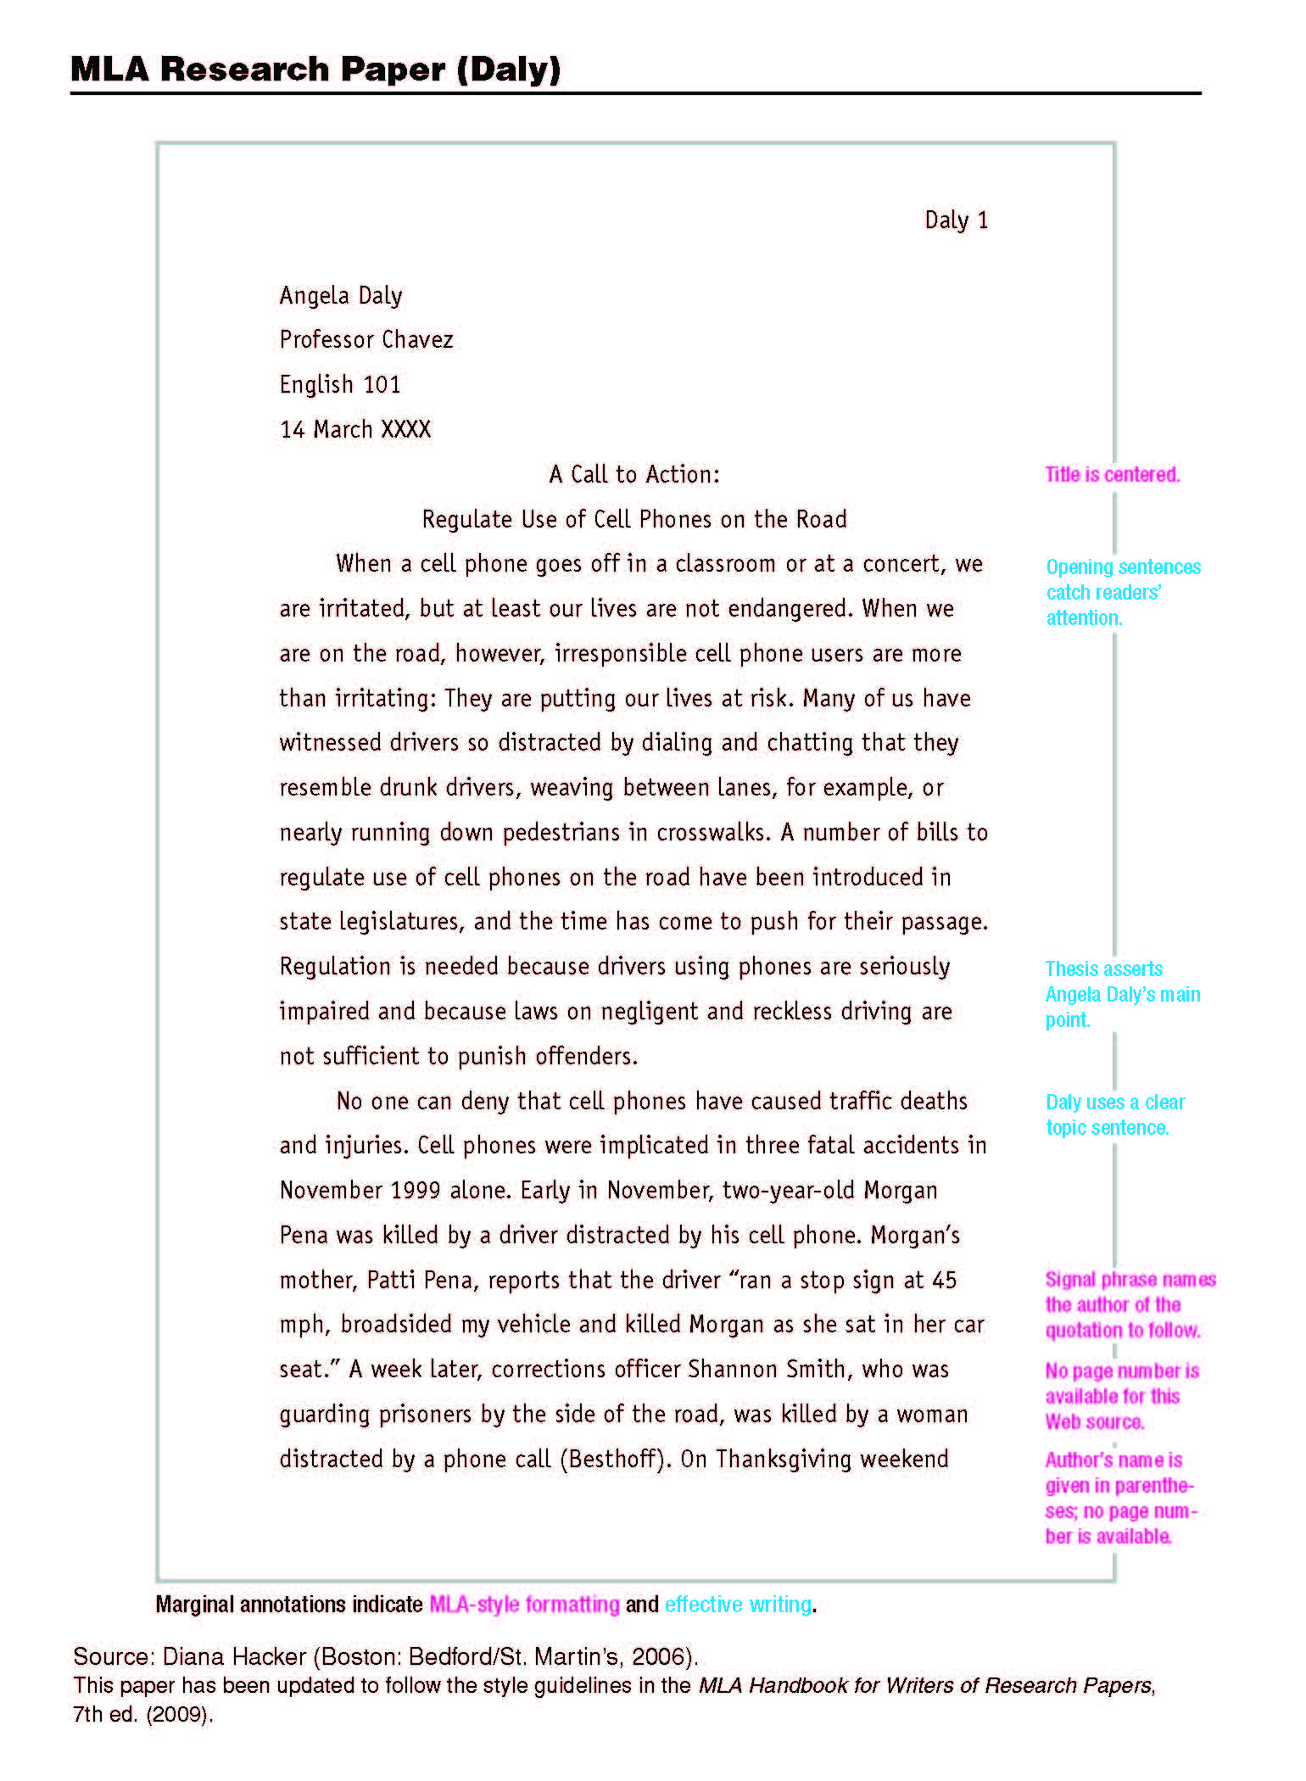
MLA Sample Research Paper
7
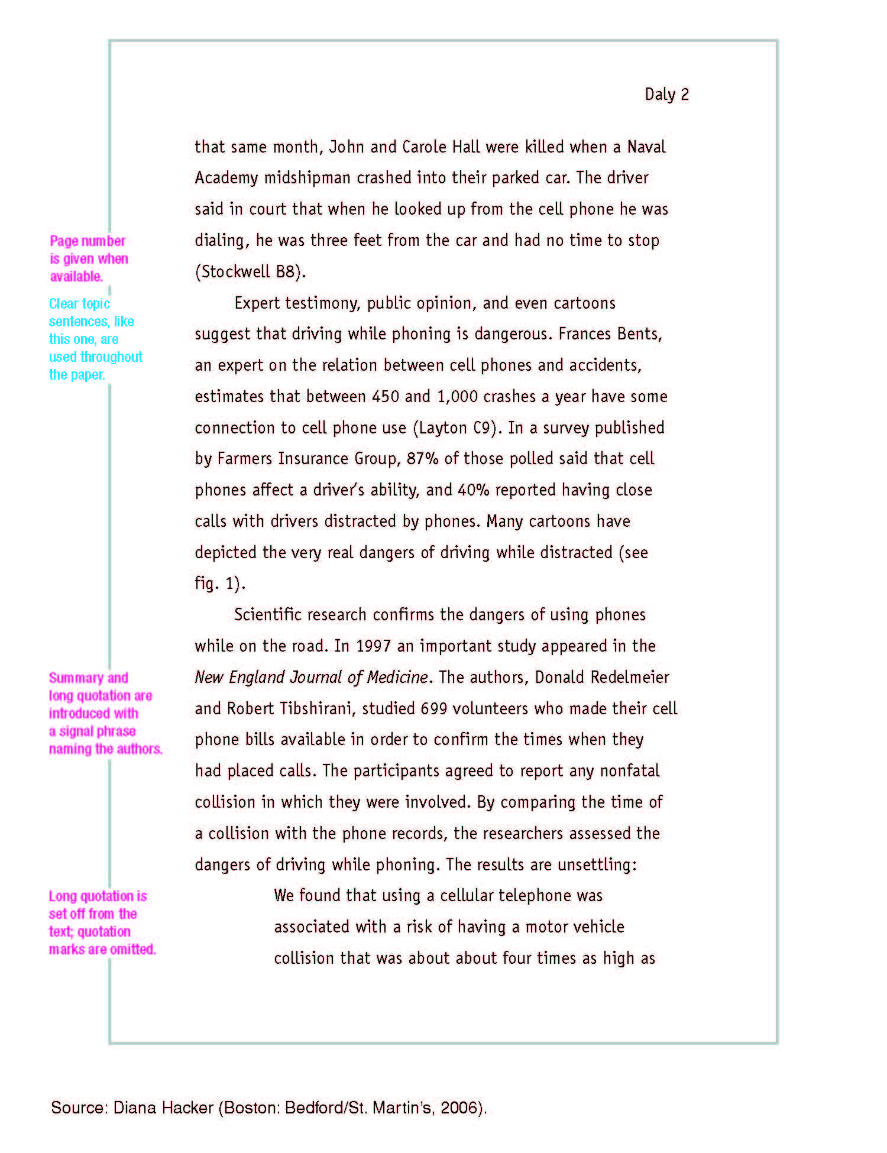
8
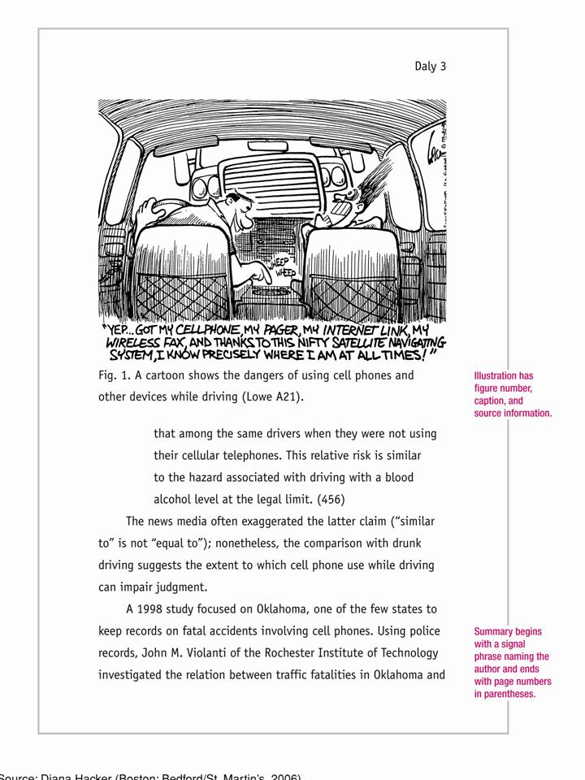
9
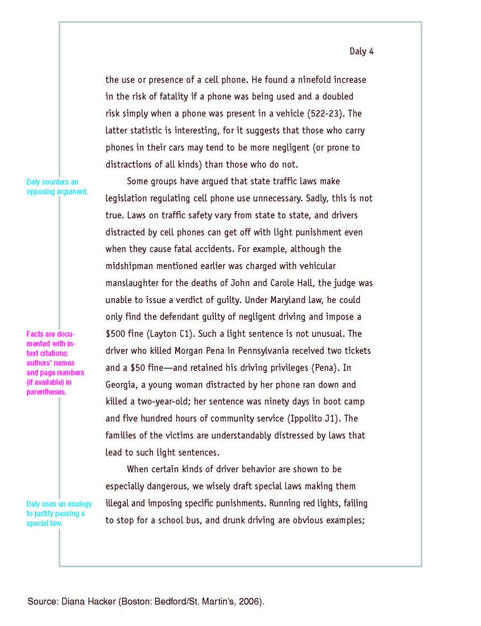
10
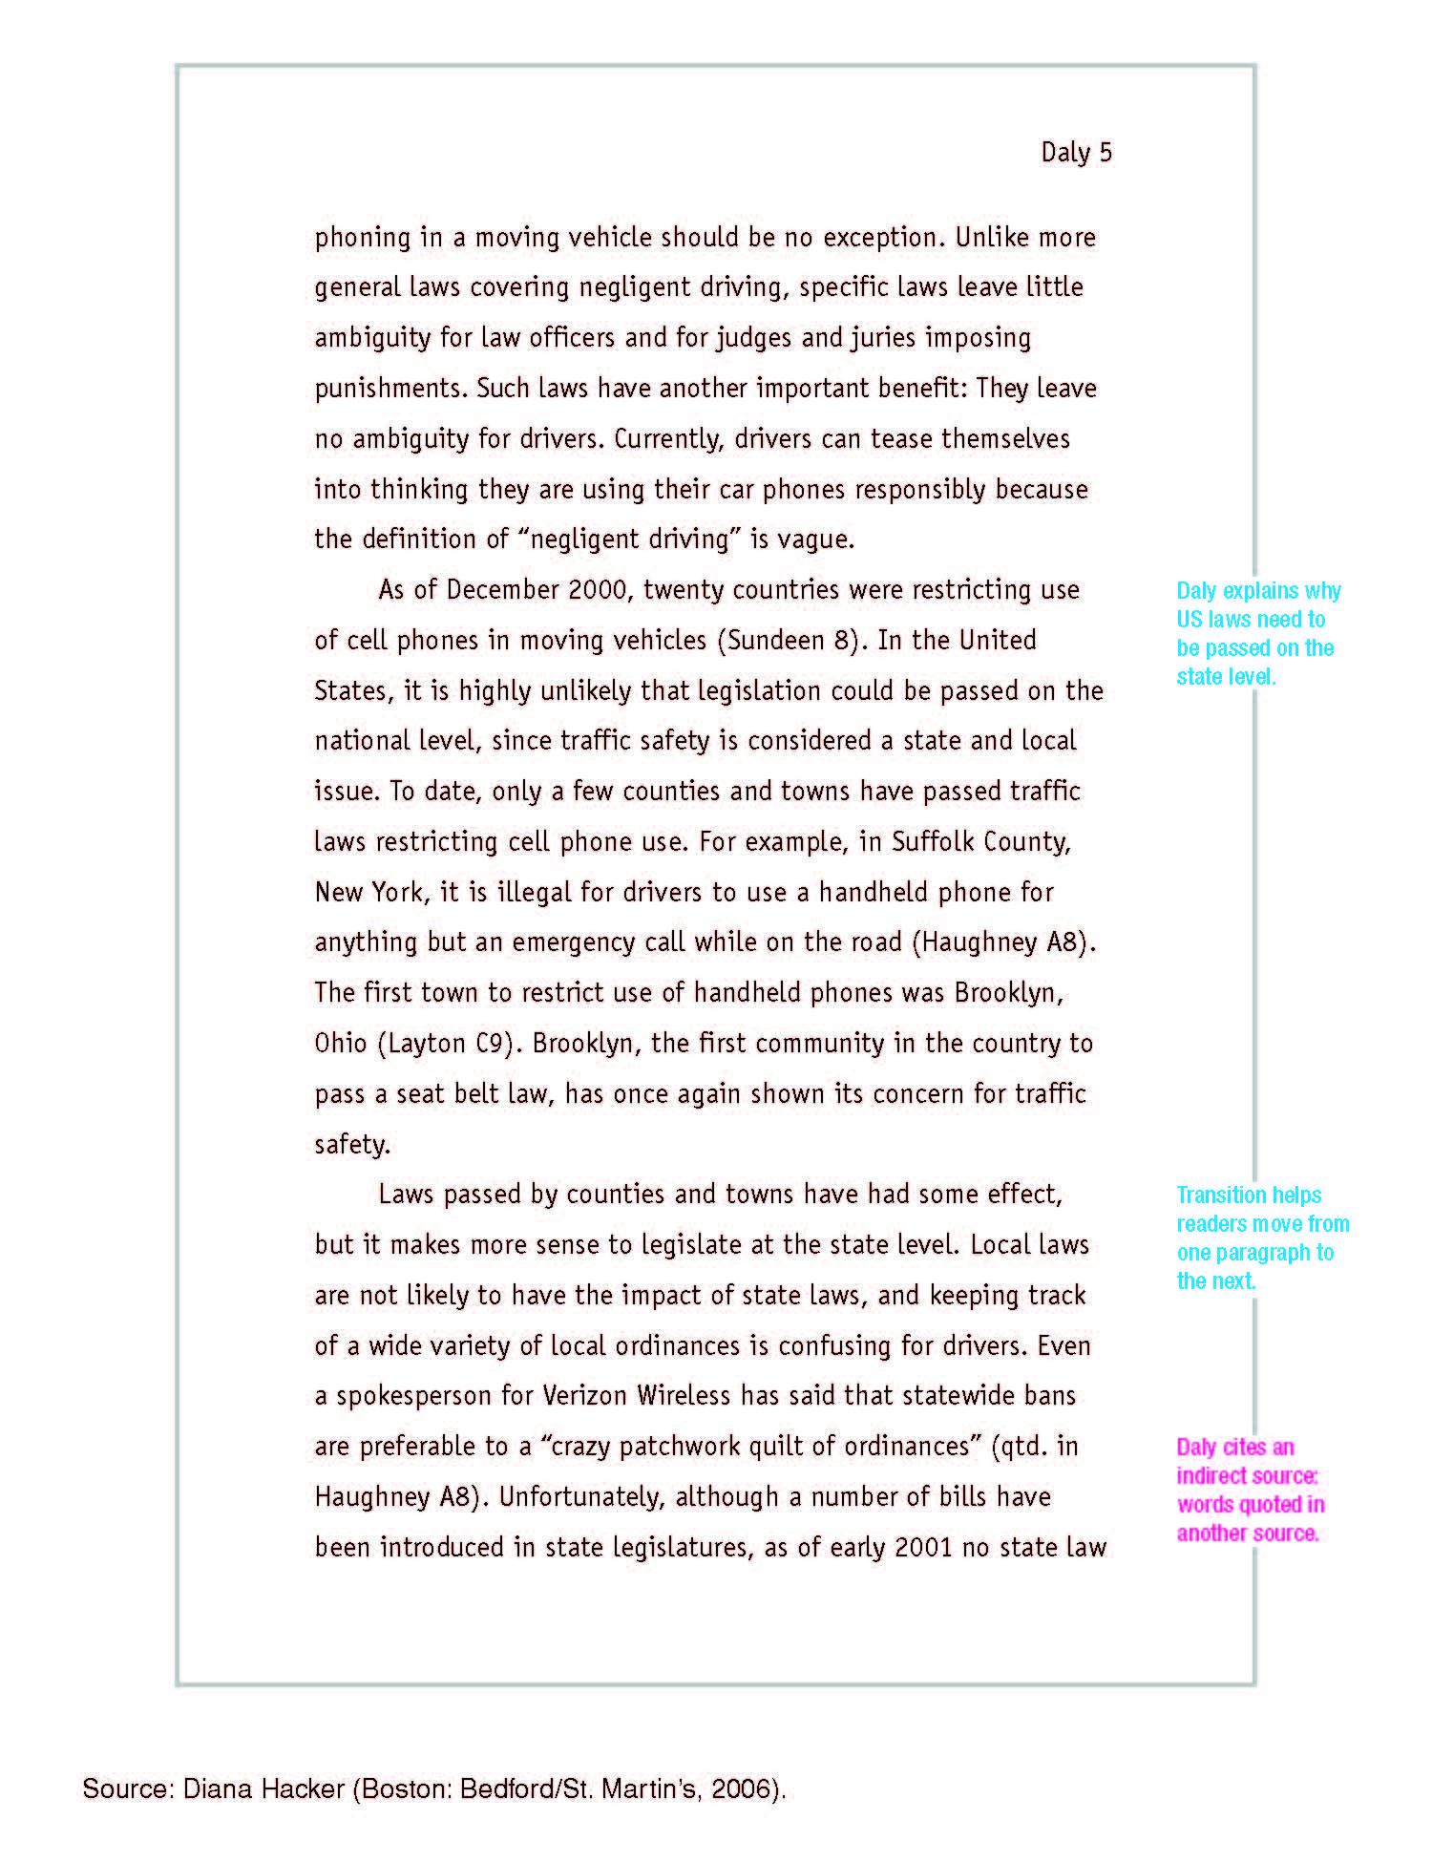
11
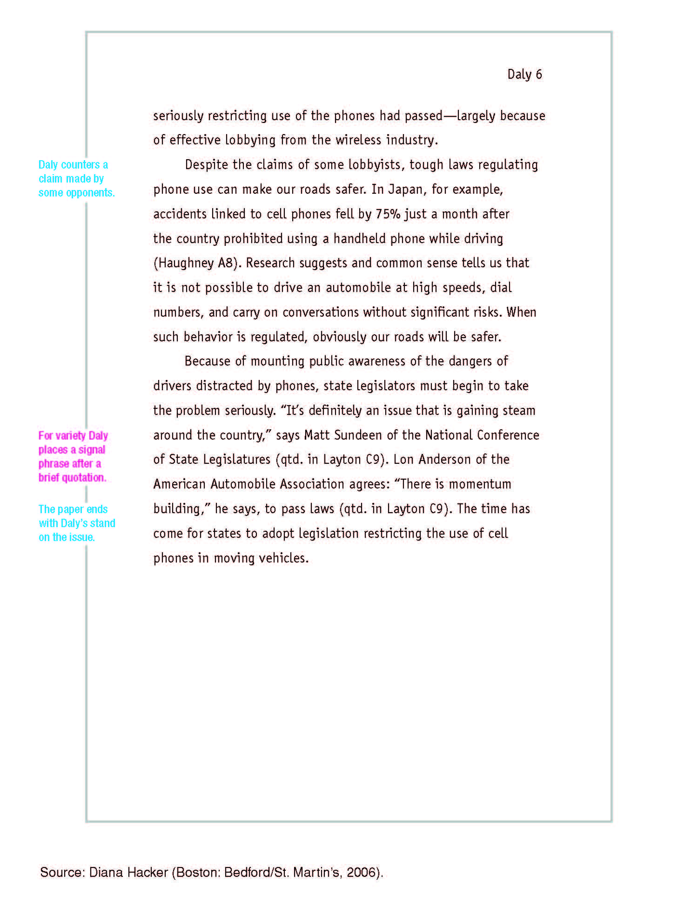
12
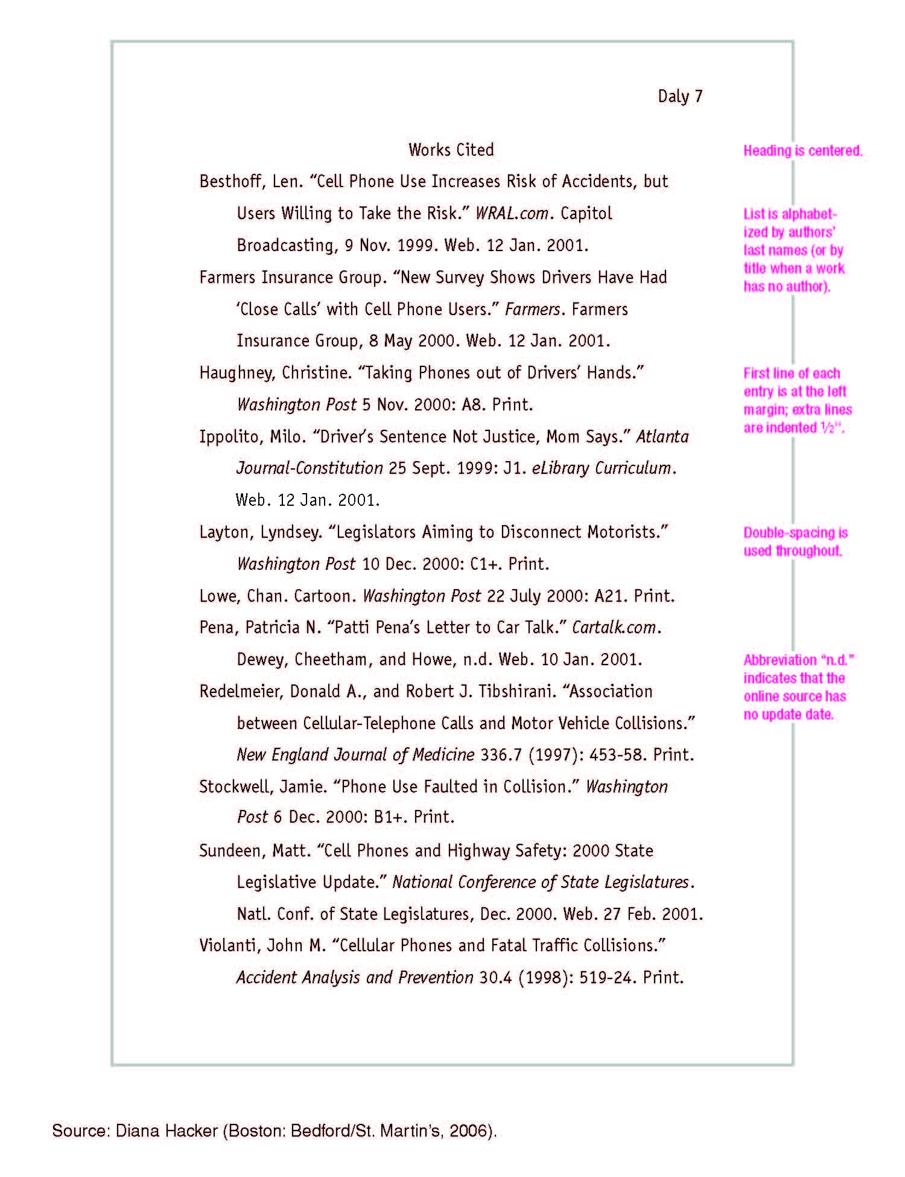
13
Works Cited Format

Works Cited

“Article Title.” Website Title. Day Month Year of Publication. Organization Sponsoring Website. Day Month Year Accessed <website address>. | Internet/  Website with no author
Author’s Last Name, First Name. “Article Title.” Magazine or Newspaper Title. Day Month year of Publication: Page(s).
 | Newspaper/ Magazine
“Article Title.” Original Magazine or Newspaper Day Month year of Publication: Pages. Database. Database Service. Library where accessed, location of library. Day Month Year Accessed <URL of service’s homepage>.
 | Database Article with no author
Author’s Last Name, First Name. Book Title. Publication City: Publishing Company, Year of Publication
 | Book
---. Same format appropriate to source by using symbol in place of author and then title of article or book. | Work by previous listed author
Author’s Last Name, First Name. “Article Title.” Original Magazine or Newspaper Day Month Year of Publication: Page(s). Database. Database Service. Library where accessed, location of library. Day Month Year Accessed <URL of service’s homepage>.
 | Database with author
Interviewee’s Last Name, First Name. Interviewee’s Title. Personal Interview. Day Month Year of Interview. | Personal Interview
Author’s Last Name, First Name. “Entry Title.” Book Title. Ed. First Name Last Name. Vol. Publication City: Publisher, Year of Publication. | Personal Interview
Same as Internet Site but beginning with author’s name directory style. | Internet/  Website with author.
Research Writing Checklist

Format of Paper:
Double space entire paper, including quotations and Works Cited page
Leave one inch margins at top, bottom, and sides of text
Indent paragraphs five spaces and indent block quotes ten spaces from left margin
Do not include a separate title page
Type heading one inch from top of first page flush with left margin
Center title for paper double-spaced after heading
Type your last name and page number one-half inch from top of each page (including page 1 and Works Cited Page) and flush with right margin
Type entire paper in 12 point font
Use of Quotations:
Keep all quotations as brief as possible. Do not use block quotes for short papers
Do not overquote
Introduce block quotes (quotes longer than 4 lines) with a colon, double spacing, and indentation of 10 spaces, without adding quotation marks
Provide a transition into quote
Integrate partial quotes smoothly into sentences for flow and grammatical correctness
Use an ellipsis (…) to indicate that you are omitting portions of the original quote
Documentation within Text:
Parenthetically document every fact, statistic, or quote in your paper
Include the author’s last name and page number in parenthesis with no comma
Include title of source if no author’s name is provided
Include only the page number when the author’s name is mentioned in the text
Place parenthetical documentation at the end of the sentence
Place end punctuation for the sentence after the parenthesis
Parenthetically document only the last fact when a series of consecutive facts come from the same page of one source
When documenting two or more works by same author, include: author’s last name, comma after the name, a shortened version of the title punctuated appropriately, and page number
Include every source that is parenthetically docuemtned on the Works Cited page
Works Cited:
Double space the Works Cited page
Alphabetize by author’s last name; if no author, alphabetize by title
Indent five spaces for the second and succeeding lines of each entry
Indicate multiple sources by the same author with three hyphens followed by a period
Include your name and the page number in upper right corner of page
Center Works Cited one inch from top of page; do not bold or underline
Include every source cited earlier in parenthetical documentation of text
Outlining

Your research paper must include your point of view as revealed through your supporting argument, and at least a glimpse at one or more opposing perspectives. Consider using one of the following structural formats for organizing your paper, or construct your own format based on one of these models.

Structure #1
I. Introduction
II. Major Supporting Argument (Point #1)
Body of Paper
III. Major Supporting Argument (Point #2)
IV. Opposing Argument
V. Challenge to Opposing Argument (Another Supporting Point)
VI. Major Supporting Argument (Point #3)
VII. Conclusion

Structure #2
I. Introduction
II. Major Supporting Argument (Point #1)
Body of Paper
III. Major Supporting Argument (Point #2)
IV. Major Supporting Argument (Point #3)
V. Opposing Argument
VI. Challenge to Opposing Argument
VII. Conclusion

Structure #3
I. Introduction
II. Major Supporting Argument (Point #1)
III. Major Supporting Argument (Point #2)
Body of Paper
IV. Opposing Argument
V. Challenge to Opposing Argument (Another Supporting Point)
VI. Major Supporting Argument (Point #3)
VII. Conclusion
The Thesis Statement

An argumentative paper makes a claim about a topic and justifies this claim with specific evidence. The claim could be an opinion, a policy proposal, an evaluation, a cause-and-effect statement, or an interpretation. The goal of the argumentative paper is to convince the audience that the claim is true based on the evidence provided.

Your thesis statement should be specific—it should cover only what you will discuss in your paper and should be supported with specific evidence.

The thesis statement usually appears at the end of the first paragraph of a paper.

To arrive at your thesis statement, simply answer your essential question.

Your topic may change as you write, so you may need to revise your thesis statement to reflect exactly what you have discussed in the paper.

Transitions

Transitions are words and phrases that act as bridges to link your ideas from sentences to sentence and that act as guideposts to indicate the direction of your thoughts. Use transitions logically to clarify the relationships between ideas in different sentences and paragraphs.

Here is a list of some common transitional devices that can be used to cue readers in a given way:

To show a time sequence, use…
Next | Before | Earlier | As soon as
Later | Then | At the same time | Soon after
Meanwhile | Now | First | In the meantime
Eventually | During | Secondly | Afterward
Finally | After | Lastly

To compare or contrast, use…
Likewise | Conversely | Although | Unlike
On the contrary | Even though | On the other hand | Nevertheless
In contrast | Similarly | But | In the same way
However | Yet

To show cause and effect, use…
So | Then | Therefore | As a result of
Because of | On account of | Thus | For this reason
Consequently

To add more information, use…
Also | And | Too | Furthermore
In addition | Again | First | As well as
Another | Secondly | Moreover | Next
Thirdly | Besides | Similarly

To strengthen or emphasize a point, use…
Indeed | Without a doubt | In other words | Obviously
In fact | Especially | Basically

To summarize, use…
With this in mind | On the whole | To this end | Lastly
All things considered | In closing | Finally | In conclusion

To introduce examples or explanations, use…
For example | Namely | In particular | Also
For instance | As an example | That is | In other words
As an illustration | For this reason

When using transitions, be sure the transition you select fits your intended meaning. For assistance, reference the table below, which provides sample sentences before and after transitions have been incorporated.

Without Transition |  |  | With Transition
George and Al disappeared into another room. They emerged wearing clown costumes. |  |  | George and Al disappeared into another room. They appeared in a few minutes wearing clown costumes. (Note: The transition indicates time)
North Americans often serve hot chocolate with whipped cream. South Americans often add cinnamon and sometimes orange rind. |  |  | North Americans often serve hot chocolate with whipped cream. South Americans, on the other hand, often add cinnamon and sometimes orange rind. (Note: The transition indicates contrast)
Ken asked his friends to help clean up the vacant lot. He enlisted the help of the neighbors. |  |  | Ken asked his friends to help clean up the vacant lot. He enlisted the help of the neighbors as well. (Note: The transition indicates added information.)
We waited endlessly for a package from home. One arrived on the day we least expected it. |  |  | We waited endlessly for a package from home. Finally, one arrived on the day we least expected it. (Note: The transition indicates time)

Use of Quotations

You may put a quotation at the beginning, middle, or end of your sentence, or for the sake of variety or better style, divide it by your own words. The sentence period follows the parenthetical reference.

Joseph Conrad writes of the company manager in Heart of Darkness, “he was obeyed, yet he inspired neither love nor fear, nor even respect” (55.)

Or

“He was obeyed,” writes Joseph Conrad of the company manager in Heart of Darkness, “yet he inspired neither love nor fear, nor even respect” (55).

Or

“He was obeyed, yet he inspired neither love nor fear, nor respect,” writes Joseph Conrad of the company manager in Heart of Darkness (55).

Indicate the omission of material from a quotation with a bracket and an ellipsis.

In surveying various response to plagues in the Middle Ages, Barbara W. Tuchman writes, “Medical thinking, trapped in the theory of astral influences, stressed air as the communicator of disease […]” (101-02).

If a quotation runs to more than four lines in your paper, set it off from your text by beginning a new line, indenting one inch from the left margin, and typing it double-spaced, without adding quotation marks. A colon introduces a quotation displayed in this way.

At the conclusion of Lord of the Flies, Ralph and the other boys realize the horror of
their actions:
The tears began to flow and sobs shook him. He gave himself up to them now for the first time on the island; great, shuddering spasms of grief that seemed to wrench his whole body. His voice rose under the black smoke before the burning wreckage of the island; and infected by that emotion, the other little boys began to shake and sob too. (186).

This handbook has been adopted and modified from the Penfield High School Research Handbook

