Essential Question Paper
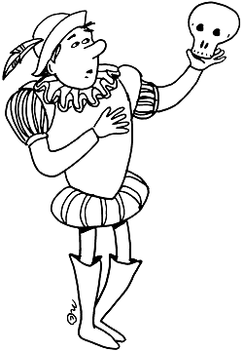
Hamlet

Objective & Overview

☺ For this paper of 2-3 pages in length, you are to respond to one of the following questions as it pertains to the play:
☺ What is the virtue of revenge?

☺How does one live in a world where tears of sorrow, loving smiles, & friendly words are suspect because all are “actions that a man might play?”

☺To what extent is love defective?

● It is imperative that you use the play to support and defend your position

● Try to embed your quotes

● This is no different than other essays you’ve written this year – go syllogistically

● In addressing the question, you can draw upon other resources (personal experience, research, data, etc.)

● Keep the Critical Lens Recipe in mind – this isn’t all that different!!

