Coming up in class
In Fundations this week, we will finish Unit 7 with the unit test on Wednesday. Students should be able to read and spell words with the “glued” sounds ang, ing, ong, ung, ank, ink, onk, and unk.
In math this week, we will wrap up our third unit by collecting data, sorting it, and representing it in graphs. Students will also be able to ask and answer questions about data points on given graphs.
In writing last week, students wrote opinion pieces about their favorite places in Henrietta, giving two or three reasons to support their opinions. This week, they will type these pieces on their Chromebooks and add an image of their favorite place.
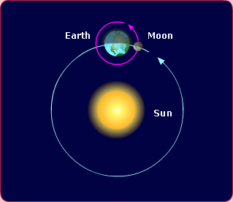
Later this week, Miss Carson will begin an exciting science unit on patterns and relationships of the earth, sun, and moon. During this unit, students will learn about how the earth rotates to make day and night, how the earth orbits the sun to make our four seasons, and how the moon orbits the earth and reflects sunlight to make phases of the moon.
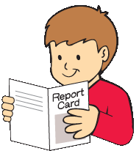


Talk to kids about their report cards
Last Friday, your child brought home his/her second quarter report card. Have you showed and talked with your child about it? By sharing and talking about specific report card grades and comments, you let your child know that how he/she does in school is important to you. Point out the areas in which your child has improved since the first quarter and encourage him/her to keep up the good work. Show your child the areas in which he/she is successfully meeting or exceeding standards and praise his/her hard work. Discuss with your child areas in which he/she is still working toward standards and set a goal for working together to help your child improve, such as practicing trick words or math fact flashcards every evening.
Please remember to keep all of the assessment items that were sent home Friday and return the signed envelope!

