EB White’s “Walden”
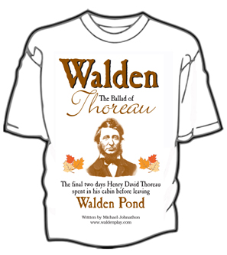
& Thoreau’s Walden
Essay Overview

Directions:
☺ For this essay you are to compare Thoreau’s Walden to EB White’s “Walden.” Here’s a partial list of some things to consider:
□ Theoretical and/or critical similarities between both texts (binaries, juxtapositions, ironies, paradoxes, tensions, dichotomous pairings)

□ Similarities in form, structure, style, and technique

□ Social commentary

□ Ideological similarities

□ Syntax, tone, diction

□ The logical structuring of both pieces
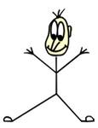Make certain to have one unifying thesis statement!!
Proceed syllogistically through your analysis
Be thorough!!

