Boy Gets Girl
and
Swimfan
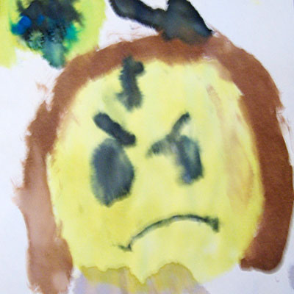
Essential Question Essay

☺ Directions & Overview
In preparation for this essay, we will view a movie entitled Swimfan – a film that thematically and stylistically mirrors Boy Gets Girl. Here’s what you need to do:

□ Write a 2-3 page essay that explores one of the following essential questions as it pertains to both Boy Gets Girl & Swimfan:
● Why is rejection so hard to swallow?
● To what extent is love merely self-indulgence?
● Under what circumstances can – “Don’t ever call me again”
actually mean – “Hey, [s]he’s actually talking to me”?

□ Unify both texts with one thesis statement
□ Your essay will need a minimum of 4 direct textual references from the play and 4 direct textual references from the movie

□ Your literary analysis of the texts will need to delve deeper than plot similarities. As always, consider other relevant literary terms such as irony, conflict, characterization, theme, etc.

