Plato

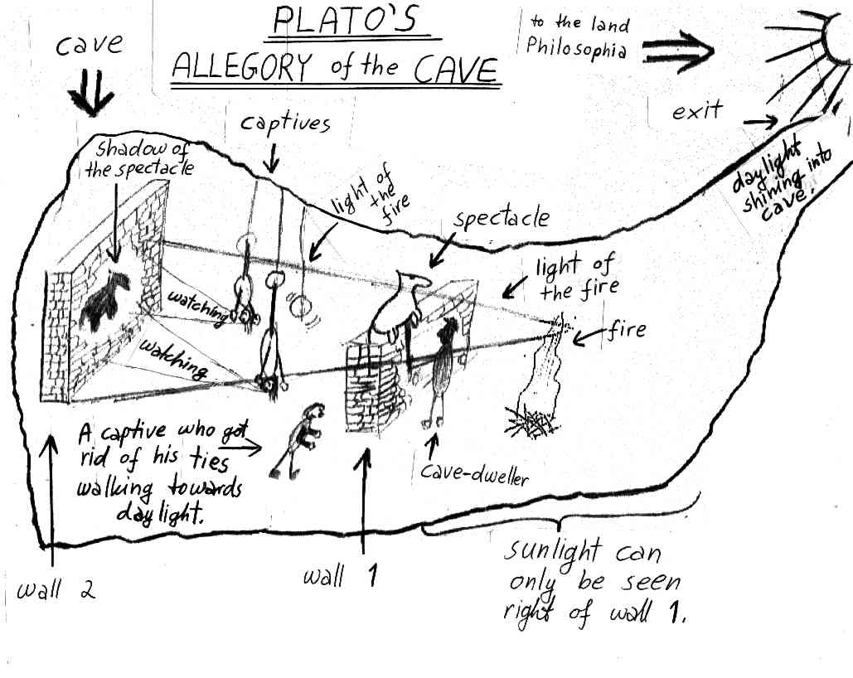

The Allegory of the Cave, from The Republic

Plato, the most creative and influential of Socrates' disciples, wrote dialogues, in which he frequently used the figure of Socrates to espouse his own (Plato's) full-fledged philosophy. In "The Republic," Plato sums up his views in an image of ignorant humanity, trapped in the depths and not even aware of its own limited perspective. The rare individual escapes the limitations of that cave and, through a long, tortuous intellectual journey, discovers a higher realm, a true reality, with a final, almost mystical awareness of Goodness as the origin of everything that exists. Such a person is then the best equipped to govern in society, having a knowledge of what is ultimately most worthwhile in life and not just a knowledge of techniques; but that person will frequently be misunderstood by those ordinary folks back in the cave who haven't shared in the intellectual insight. If he were living today, Plato might replace his rather awkward cave metaphor with a movie theater, with the projector replacing the fire, the film replacing the objects which cast shadows, the shadows on the cave wall with the projected movie on the screen, and the echo with the loudspeakers behind the screen. The essential point is that the prisoners in the cave are not seeing reality, but only a shadowy representation of it. The importance of the allegory lies in Plato's belief that there are invisible truths lying under the apparent surface of things which only the most enlightened can grasp. Used to the world of illusion in the cave, the prisoners at first resist enlightenment, as students resist education. But those who can achieve enlightenment deserve to be the leaders and rulers of all the rest. At the end of the passage, Plato expresses another of his favorite ideas: that education is not a process of putting knowledge into empty minds, but of making people realize that which they already know. This notion that truth is somehow embedded in our minds was also powerfully influential for many centuries.
Judging by this passage, why do you think many people in the democracy of Athens might have been antagonistic to Plato's ideas? What does the sun symbolize in the allegory?

Is a resident of the cave (a prisoner, as it were) likely to want to make the ascent to the outer world? Why or why not? What does the sun symbolize in the allegory? And now, I said, let me show in a figure how far our nature is enlightened or unenlightened:--Behold! human beings living in an underground den, which has a mouth open towards the light and reaching all along the den; here they have been from their childhood, and have their legs and necks chained so that they cannot move, and can only see before them, being prevented by the chains from turning round their heads. Above and behind them a fire is blazing at a distance, and between the fire and the prisoners there is a raised way; and you will see, if you look, a low wall built along the way, like the screen which marionette players have in front of them, over which they show the puppets.
I see.
And do you see, I said, men passing along the wall carrying all sorts of vessels, and statues and figures of animals made of wood and stone and various materials, which appear over the wall? Some of them are talking, others silent.
You have shown me a strange image, and they are strange prisoners.
Like ourselves, I replied; and they see only their own shadows, or the shadows of one another, which the fire throws on the opposite wall of the cave?
True, he said; how could they see anything but the shadows if they were never allowed to move their heads?
And of the objects which are being carried in like manner they would only see the shadows?
Yes, he said.
And if they were able to converse with one another, would they not suppose that they were naming what was actually before them?
Very true.
And suppose further that the prison had an echo which came from the other side, would they not be sure to fancy when one of the passers-by spoke that the voice which they heard came from the passing shadow?
No question, he replied.
To them, I said, the truth would be literally nothing but the shadows of the images.
That is certain.
And now look again, and see what will naturally follow if the prisoners are released and disabused of their error. At first, when any of them is liberated and compelled suddenly to stand up and turn his neck round and walk and look towards the light, he will suffer sharp pains; the glare will distress him, and he will be unable to see the realities of which in his former state he had seen the shadows; and then conceive some one saying to him, that what he saw before was an illusion, but that now, when he is approaching nearer to being and his eye is turned towards more real existence, he has a clearer vision,--what will be his reply? And you may further imagine that his instructor is pointing to the objects as they pass and requiring him to name them,--will he not be perplexed? Will he not fancy that the shadows which he formerly saw are truer than the objects which are now shown to him?
Far truer.
And if he is compelled to look straight at the light, will he not have a pain in his eyes which will make him turn away to take refuge in the objects of vision which he can see, and which he will conceive to be in reality clearer than the things which are now being shown to him?
True, he said.
And suppose once more, that he is reluctantly dragged up a steep and rugged ascent, and held fast until he is forced into the presence of the sun himself, is he not likely to be pained and irritated? When he approaches the light his eyes will be dazzled, and he will not be able to see anything at all of what are now called realities.
Not all in a moment, he said.
He will require to grow accustomed to the sight of the upper world. And first he will see the shadows best, next the reflections of men and other objects in the water, and then the objects themselves; then he will gaze upon the light of the moon and the stars and the spangled heaven; and he will see the sky and the stars by night better than the sun or the light of the sun by day?
Certainly.
Last of all he will be able to see the sun, and not mere reflections of him in the water, but he will see him in his own proper place, and not in another; and he will contemplate him as he is.
Certainly.
He will then proceed to argue that this is he who gives the season and the years, and is the guardian of all that is in the visible world, and in a certain way the cause of all things which he and his fellows have been accustomed to behold?
Clearly, he said, he would first see the sun and then reason about him.
And when he remembered his old habitation, and the wisdom of the den and his fellow-prisoners, do you not suppose that he would felicitate himself on the change, and pity them?
Certainly, he would.
And if they were in the habit of conferring honors among themselves on those who were quickest to observe the passing shadows and to remark which of them went before, and which followed after, and which were together; and who were therefore best able to draw conclusions as to the future, do you think that he would care for such honors and glories, or envy the possessors of them? Would he not say with Homer,
Better to be the poor servant of a poor master, and to endure anything, rather than think as they do and live after their manner? (1)
Yes, he said, I think that he would rather suffer anything than entertain these false notions and live in this miserable manner.
Imagine once more, I said, such a one coming suddenly out of the sun to be replaced in his old situation; would he not be certain to have his eyes full of darkness?
To be sure, he said.
And if there were a contest, and he had to compete in measuring the shadows with the prisoners who had never moved out of the den, while his sight was still weak, and before his eyes had become steady (and the time which would be needed to acquire this new habit of sight might be very considerable), would he not be ridiculous? Men would say of him that up he went and down he came without his eyes; (2)and that it was better not even to think of ascending; and if any one tried to loose another and lead him up to the light, let them only catch the offender, and they would put him to death. (3)
No question, he said.
This entire allegory, I said, you may now append, dear Glaucon, to the previous argument; the prison-house is the world of sight, the light of the fire is the sun, and you will not misapprehend me if you interpret the journey upwards to be the ascent of the soul into the intellectual world according to my poor belief, which, at your desire, I have expressed--whether rightly or wrongly God knows. But whether true or false, my opinion is that in the world of knowledge the idea of good appears last of all, and is seen only with an effort; and, when seen, is also inferred to be the universal author of all things beautiful and right, parent of light and of the lord of light in this visible world, Here Plato describes his notion of God in a way that was influence profoundly Christian theologians. and the immediate source of reason and truth in the intellectual; and that this is the power upon which he would act rationally either in public or private life must have his eye fixed.
I agree, he said, as far as I am able to understand you.
Moreover, I said, you must not wonder that those who attain to this beatific vision are unwilling to descend to human affairs; for their souls are ever hastening into the upper world where they desire to dwell; which desire of theirs is very natural, if our allegory may be trusted.
Yes, very natural.
And is there anything surprising in one who passes from divine contemplations to the evil state of man, misbehaving himself in a ridiculous manner; if, while his eyes are blinking and before he has become accustomed to the surrounding darkness, he is compelled to fight in courts of law, or in other places, about the images or the shadows of images of justice, and is endeavoring to meet the conception of those who have never yet seen absolute justice?
Anything but surprising, he replied.
Any one who has common sense will remember that the bewilderments of the eyes are of two kinds, and arise from two causes, either from coming out of the light or from going into the light, which is true of the mind's eye; and he who remembers this when he sees any one whose vision is perplexed and weak, will not be too ready to laugh; he will first ask whether that soul of man has come out of the brighter life, and is unable to see because unaccustomed to the dark, or having turned from darkness to the day is dazzled by excess of light. And he will count the one happy in his condition and state of being, and he will pity the other; or, if he have a mind to laugh at the soul which comes from below into the light, there will be more reason in this than in the laugh which greets him who returns from above out of the light into the den.
That, he said, is a very just distinction.
But then, if I am right, certain professors of education must be wrong when they say that they can put a knowledge into the soul which was not there before, like sight into blind eyes.
They undoubtedly say this, he replied.
Whereas our argument shows that the power and capacity of learning exists in the soul already; and that just as the eye was unable to turn from darkness to light without the whole body, so too the instrument of knowledge can only by the movement of the whole soul be turned from the world of becoming into that of being, and learn by degrees to endure the sight of being and of the brightest and best of being, or in other words, of the good.
Translated by Benjamin Jowett

(1) This refers to a famous passage in Homer's Odyssey in which the ghost of the great hero Achilles, when asked if he is not proud of the fame his deeds has spread throughout the world, answers that he would rather be a slave on a worn-out farm than king over all of the famous dead. Interestingly, Plato quotes the same passage elsewhere as disapprovingly as depicting life after death in such a negative manner that it may undermine the willingness of soldiers to die in war.
(2) The comic playwright Aristophanes had mocked Socrates by portraying Plato's master, Socrates, as a foolish intellectual with his head in the clouds.
(3) Plato undoubtedly has in mind the fact that the Athenians had condemned to death his master Socrates, who Plato considered supremely enlightened.

 | This is an excerpt from Reading About the World, Volume 1, edited by Paul Brians, Mary Gallwey, Douglas Hughes, Azfar Hussain, Richard Law, Michael Myers Michael Neville, Roger Schlesinger, Alice Spitzer, and Susan Swan and published by Harcourt Brace Custom Publishing.  The reader was created for use in the World Civilization course at Washington State University, but material on this page may be used for educational purposes by permission of the editor-in-chief:

