Hamlet
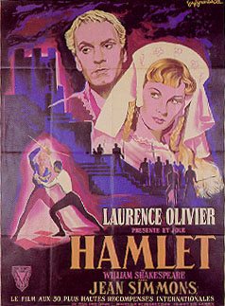
Act I Translations

I, ii King 1-38
King 90-120
Hamlet 133 –164

I, iii Laertes 13-48
Polonius 60-88
Polonius 124-144

I, iv Hamlet 14-40
Hamlet 44-63

I, V Ghost 13-29
Ghost 38 –48
Ghost 49-98
Hamlet 99-115
Hamlet 186-202
Hamlet 203-212

