

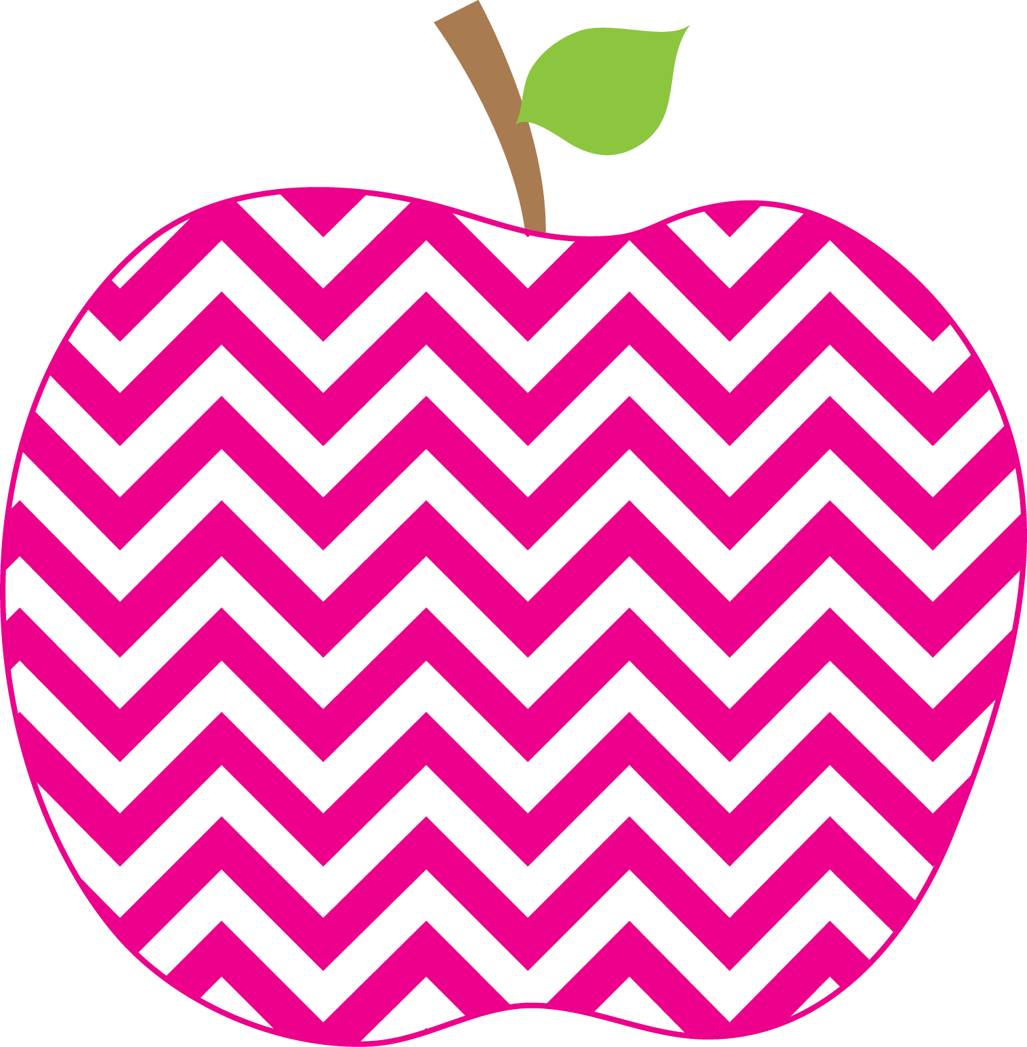



Mrs. Bagley’s Class Class Weekly
September 4th – 7th

Homework: Please check your child’s backpack each night. He or she will bring home a “Go Home” folder nightly, with any homework and/or
handouts for you. It is important that you go through papers in your child’s folder: take out anything that does not need to be returned to
school and pay attention to those papers in need of your response. I will soon begin to send home a weekly homework sheet with directions.

Next week your child will bring home a reading bag with a book that can be read independently. Take the time to listen as your child reads. If they need help, jump in and help with the difficult word. Encourage them to use the picture to understand the text. After this independent book, please have your child read books from your home library. You can spend time reading more difficult books to them. Take time to stop and ask questions about the book. Have your child give a retelling of the book at the end. Make reading time fun!!

Save the date:
Wednesday, October 10th (6:30-7:30) is our Get Acquainted Night. I will present the first grade curriculum to you and you will have a chance to see what your child works on at school each day.

This Week’s Focus
Back to School
Bathroom: Please review with your child the correct way to use the bathroom and wash and dry their hands after. We have had MANY accidents causing us to not be able to use the bathroom until it gets cleaned.

Lunch: Please preview the menu with your child the night before so they are aware of the choices and they can select a menu choice that they will eat and enjoy.
Fall Fundraiser packets - Please read the note that came home with the packet and return if you are not selling them.

Please return by September 21st.

Feel free to contact me anytime ☺
Phone: (585) 359-5430
E-mail: abagley@rhnet.org
Webpage: http://www.rhnet.org/webpages/abagley
Reminders
Contact Information

